May 2022

Initial Risk Assessment

Audit of the UNESCO

Office in Harare

**Declaration of non-conflict of interest: The audit team has read and understood the Code of Ethics for Internal Auditors. The audit team agrees to adhere to the Code of Ethics and, should the audit team have any questions or encounter any circumstances potentially impairing the adherence to the Code such as conflict of interest, the audit team will immediately bring them to the attention of their supervisor or to the IOS Director.**

During the preparation of IRA, please comply with the IIA Standard 1220.A1. – Internal auditors must exercise due professional care by considering the:

* Extent of work needed to achieve the engagement’s objectives;
* Relative complexity, materiality, or significance of matters to which assurance procedures are applied;
* Adequacy and effectiveness of governance, risk management, and control processes;
* Probability of significant errors, fraud, or noncompliance; and
* Cost of assurance in relation to potential benefits.

CONTENTS

1 BACKGROUND 3

2 UN AGENCIES 5

3 OFFICE STRATEGY, STRUCTURE AND PORTFOLIO 5

4 PARTNERSHIPS 16

5 RISK MANAGEMENT 20

6 CONTROL ACTIVITIES 20

7 DATA ANALYSIS 23

8 INFORMATION AND COMMUNICATION 26

9 PRELIMINARY FINDINGS 26

10 AUDIT RATIONALE, SCOPE AND OBJECTIVE 26

11 Annex 1 – Risk Matrix and Work Programme 29

Engagement Terms of Reference 30

*Title of the Audit* 30

|  |
| --- |
| BACKGROUND |

1. Office Role

The UNESCO Office in Harare was initially established in 1986 as a sub-regional office for education in Southern Africa. Its main focus was on higher education, following a recommendation of the Fifth UNESCO Conference of Minister of Education in Africa (1982). Since then, it has also played the role of Cluster Office, covering four countries (Botswana, Malawi, Zambia and Zimbabwe). As a Cluster Office, it covered UNESCO’s five areas of competence, namely Education, Natural Sciences, Social and Human Sciences, Culture and Communication and Information. Since 2014, the Harare Office became the new Multi Regional Office (MRO) for Southern Africa covering nine countries: Botswana, Lesotho, Malawi, Mozambique, Namibia, South Africa, Eswatini, Zambia and Zimbabwe.

The office also serves as UNESCO’s focal point for cooperation with the Southern African Development Community (SADC) as well as for the Common Market for Eastern and Southern Africa (COMESA). As shown on the figure below, under Harare Regional Office, there are two National Office in Mozambique (Maputo) and Namibia (Windhoek), as well as antennas in Botswana, Lesotho, Malawi, South Africa and Zambia.

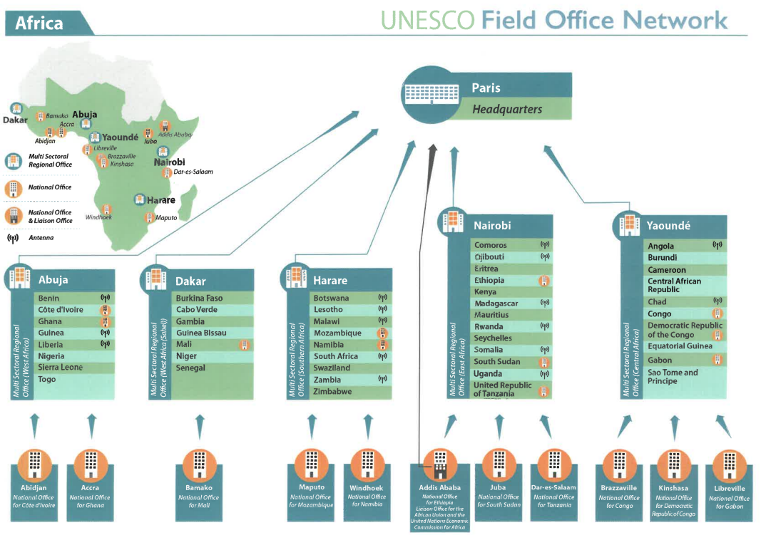

As a Regional Office, Harare covers all five UNESCO Programme Sectors, i.e. ED, SC, CLT, SHS and CI with a primary focus on ED and SC.

PAX perspective:

* In 2013 Harare became a Regional Office. Staff were mainly brought from Namibia which became National in return.
* HCA is existent, the government pays the rent for Office premises. Even though the HCA is old dated from 1986, PAX doesn’t see an urgency to update it in order not to provoke any issues. They will discuss the HCA issue with the new Director to see her views on that.
* Harare is a very dynamic Office. A lot of staff and funds. An exemplary Office in Africa.
* For Priority Africa (PA), the Office is active. Lidia was a spokesperson for PA in the Board. In general, Zimbabwe and South Africa are very vocal about PA.
* Antennas in countries in the region are not formal. It’s mostly 1/2 persons implementing projects.

1. Context of the region

Transparency International reports that both democracy and the fight against corruption are at an all-time low in Southern Africa. The corruption perception indices (CPI) are low on a scale of 0 (very corrupt) to 100 (very clean) for most countries in the region except for Botswana with the rate of 55.

|  |  |  |  |  |
| --- | --- | --- | --- | --- |
| **Countries** | **Population** | **CPI score** | **Rank /180** | **Evolution** |
| Zimbabwe | 14,862,927 | 23 | 157 | Score changed -1 since 2020 |
| Botswana | 2,351,625 | 55 | 45 | Score changed -5 since 2020 |
| Eswatini | 1,160,164 | 32 | 122 | Score changed -1 since 2020 |
| Lesotho | 2,142,252 | 38 | 96 | Score changed -3 since 2020 |
| Malawi | 19,129,955 | 35 | 110 | Score changed +5 since 2020 |
| Mozambique | 31,255,435 | 26 | 147 | Score changed +1 since 2020 |
| Namibia | 2,540,916 | 49 | 58 | Score changed -2 since 2020 |
| South Africa | 59,308,690 | 44 | 70 | Score was the same in 2020 |
| Zambia | 18,383,956 | 33 | 117 | Score was the same in 2020 |

*Source:* [*https://www.transparency.org/en/cpi/2021*](https://www.transparency.org/en/cpi/2021) *and* [*https://data.worldbank.org/indicator/SP.POP.TOTL*](https://data.worldbank.org/indicator/SP.POP.TOTL)

1. Office Scope

The figure below shows the size of the office in terms of personnel and the volume of expenditures in Regular Programme and Extrabudgetary funds in 2020-2021.

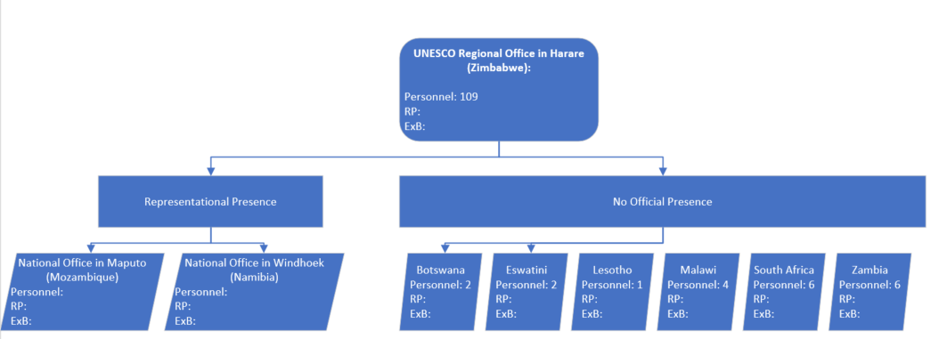

1. Office Organigramme

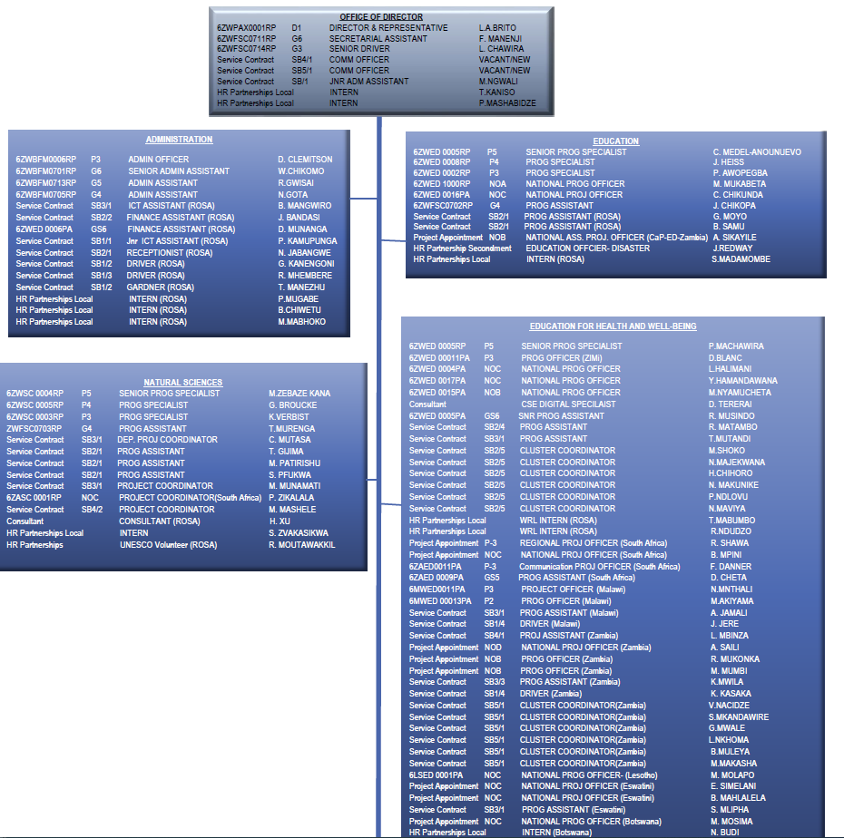The office consists of 109 employees under different contract modalities, i.e. fixed term, Project appointment, service contract holders, volunteers and secondments.

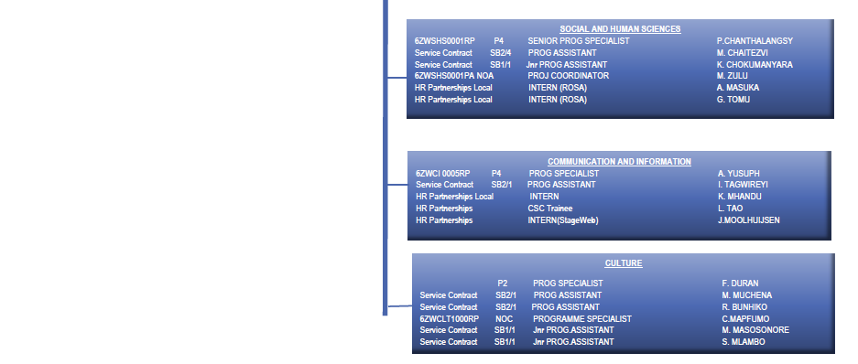

During the audit period, only 11 persons left the Office including 2 transfers outside of FO/HAR (former DIR and AO) and 1 transfer within FO/HAR, from Harare to Lilongwe. Hence, it can be concluded that the turnover is low.

|  |
| --- |
| UN AGENCIES |

**Office** UNESCO’s presence in Zimbabwe represents the third in terms of international staff and sixth in terms of overall staffing as shown below.

Zimbabwe: 25 agencies with 1070 staff, 193 being international and 877 - national.

Source: UNDSS Staff List as of March 2022

1. Strengthened UNESCO’s participation in Joint UN

Programmes cooperation with other UN agencies is very important for UNESCO. ROSA aims to strengthen UNESCO’s firm belief in UN reform and delivering as one. In this regard, close partnerships with other UN Agencies are developed to ensure coherence and synergies. The Office aims to fully participate in the designing/reviewing and implementation of The United Nations Sustainable Development Cooperation Framework (UNSDCF) in all the nine countries. Since the Office does not have physical presence in all the countries, the Office has assigned focal points to ensure UNESCO participation in Joint UN activities and takes the lead in its areas of competences.

|  |
| --- |
| OFFICE STRATEGY, STRUCTURE AND PORTFOLIO |

1. Regional Strategy

The Office developed and followed a regional strategy for Southern Africa from 2017 to 2021. This Strategy is the first integrated Regional Support Strategy in UNESCO covering all the five sectors of the Organisation. This is aligned with the Organisation’s Medium-Term Strategy (2014-2021), (37 C/4), Priority Africa, African Union Agenda SADC Regional Indicative Strategic Development and the SDGs. This Strategy also incorporated UNESCO’s Programme, Partnerships, Resource Mobilisation, and Communication and Visibility strategies thereby ensuring a comprehensive approach towards effective delivery, maximum impact and visibility. The regional strategy is further supported by a Partnerships Strategy, Resource Mobilisation Strategy and Communication and Visibility Strategy

The Office designated Focal Points for each country who acts as a point of contact and communication for NATCOMs, Government entities, RCO/UNCTs, partners and stakeholders in the respective country on any issue relating to UNESCO’s work in and with that country.

This Strategy also provides modalities of how the Regional Office works with National Offices in Maputo (Mozambique) and Windhoek (Namibia). The Strategy foresees the establishment of Project or Antenna Offices in all countries in the region as a way to establish physical presence and effective cooperation and communication at country level. UNESCO ROSA provides effective backstopping and oversight to all National Offices and Project Offices in the region.

The Strategy provided internal strategic guidelines for ROSA regional staff to streamline programming, partnerships, resource mobilisation and communication and visibility for the period 2017 to 2021.

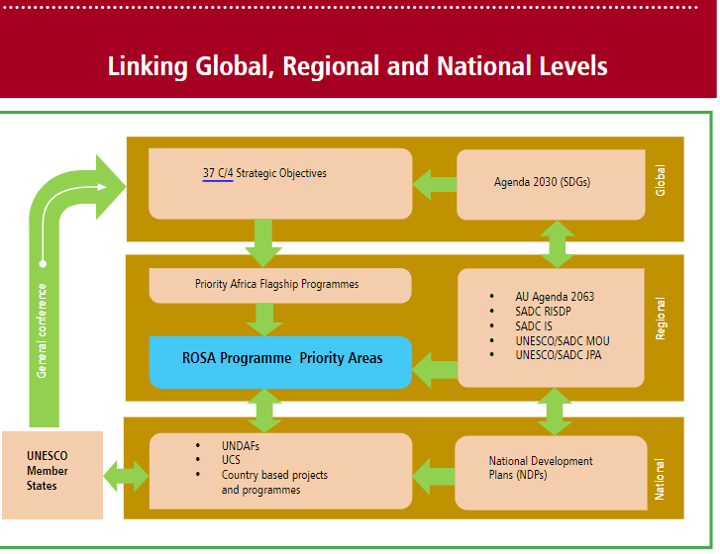

ROSA’s programme priority areas are influenced and in sync with both the UNESCO Medium Term Strategy and Priority Africa. The Regional Support Strategy is presented within the broader framework of the Agenda 2030 for Sustainable Development as well as the African Union Agenda 2063. At the same time, it is also guided by the SADC Regional Indicative Strategic Development Plan (RISDP) and the SADC Industrialisation Strategy (IS).

UNESCO ROSA and SADC have recently developed a new Framework agreement for Cooperation and a Joint Programme of Action (JPA) which identifies concrete priority areas for cooperation.

At national level, the Regional Support Strategy is linked to the National Development Plans, United Nations Development Assistance Frameworks (UNDAFs), UNESCO Country Strategies as well as country-based projects and programmes

The UNESCO Regional Office for Southern Africa’s Support Strategy is hinged on the following overall programme priority areas:

* Supporting the provision of inclusive and equitable quality education and promote lifelong learning for all;
* Strengthening the development and application of scientific and technological knowledge for social and economic development;
* Supporting inclusive social development and promoting ethical principles;
* Fostering creativity, cultural diversity and protecting, promoting and transmitting heritage;
* and Promoting freedom of expression, media development and access to information and knowledge

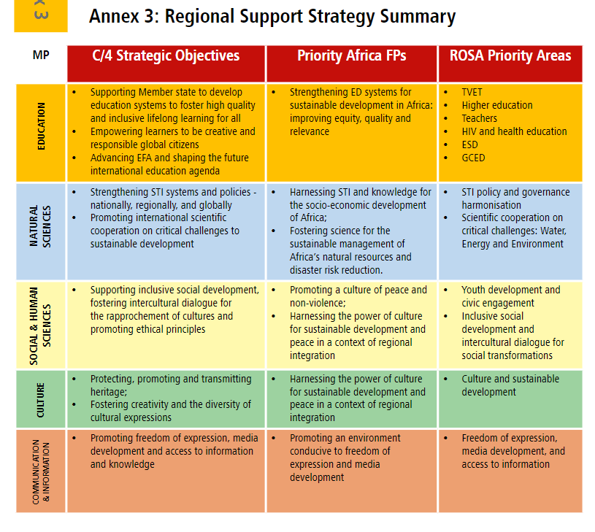

**SHS observations**

* SHS/EO believes that such kind of FO framework is unworkable and field office activities should be always aligned to UNESCO C4 and C5.
* However, on exceptional basis, it is allowed to develop frameworks, i.e. it should be for a very specific purpose, conceptualization. There is a risk to make UNESCO C/5 à la carte.
* The 2017-2021 framework was not formally evaluated. However, a hired consultant took stock of work being done at UNESCO and SADC levels.

**CI observations**

* We need to “affiner” in terms of outputs of C/5. The framework developed by former DIR is not wrong, but it’s very broad. Intersectorality needs to be factored.
* What is missing:
* Documentary heritage
* Multilingualism
* Innovation and transformation

1. Country specific programming goals

ROSA will finalise the development of UNESCO Country Strategies (UCSs) for its member states. These are developed in a participatory manner through wide consultations with key stakeholders including line Ministries and National Commissions for UNESCO. Namibia and Mozambique already have approved UCPDs and lessons learnt in their development will inform the crafting of others. The UCSs will clearly articulate UNESCO’s role within each country’s development plan as well as the Joint UN Programmes and UNSDCF. They ensure that UNESCO takes its rightful position in each country and address the specific needs of the individual countries. Of course, they are also influenced by global, regional, and sub-regional agendas.

|  |  |  |  |  |
| --- | --- | --- | --- | --- |
| **Countries** | **UNDP Human Development Index (HDI) 2020[1]** | **UNDAF Period** | **UNDAF priorities for the achievement of the SDGs** | **UCS Expected Results** |
| Zimbabwe | 0,571 | 2022-2026 | * People-centred - inclusive, equitable human development and wellbeing * Environmental protection, climate resilience and natural resources management * Economic transformation, equitable and inclusive growth * Transformative, accountable, equitable and inclusive governance | No UCS |
| Botswana | 0,735 | 2017-2021  (out-dated) | * Policy and Programme Design towards the achievement of Sustainable Development Goals targets and national aspirations * Implementation of Policies and Programmes * Data for Planning, Monitoring, Evaluation and Decision making | No UCS |
| Eswatini | 0,611 | 2021-2025 | * Priority I: Prosperity The overarching themes of this strategic priority are enabling environment; private sector investment; small and medium sized enterprise creation; sustainable agriculture; job creation including a just transition into new sectors that address climate change, decent work, food security and social protection * Priority II: People The overarching themes of this strategic priority are health; education and vocational training, accountable governance, gender equality and human rights * Priority III: Planet The overarching themes in this strategic priority area are climate change resilience and adaptation; water management; food security and renewable energy; and just transition to environmental sustainability | Draft UCS not finalized |
| Lesotho | 0,527 | 2019-2023 | * Accountable Governance, Effective Institutions, Social Cohesion and Inclusion * Sustainable Human Capital Development * Sustainable and Inclusive Economic Growth for Poverty Reduction | * ED: support full implementation of the ESA Ministerial Commitment through provision of rights based, age -appropriate and culturally relevant Comprehensive Sexuality Education for adolescents and young people of Lesotho * SC: conservation of nature through community participation; Biosphere; SADC cooperation * SHS: Advancing the Rights of Persons with Disabilities in Lesotho; Strengthening Bio-Ethics; Supporting Youth Civic Engagement * CLT: Supporting cultural Institutions and associations & national capacities * CI: Promoting Freedom of Expression and Safety of Journalists; Advocating Media Pluralism and Media Diversity |
| Malawi | 0,483 | 2019-2023 | * Peace, Inclusion and Effective Institutions * Population Management and Inclusive Human Development * Inclusive and Resilient Growth | * ED: Continue to build on successes in reforming TVET sector; partnership with EU * SC: Identification of hydro climatic products; interventions with SADC * SHS: youth, inclusion of disadvantaged groups’ rights; mgt of social transformation, intercultural dialogue, bioethics * CLT: support of convention implementation and it’s follow-up * CI: empowering media to support SGDs awareness and implementation |
| Mozambique | 0,456 | 2022-2026 | * HUMAN DEVELOPMENT * ECONOMIC DIVERSIFICATION AND SUSTAINABLE LIVELIHOODS * CLIMATE RESILIENCE AND SUSTAINABLE USE OF NATURAL RESOURCES * PEACEBUILDING, HUMAN RIGHTS AND INCLUSIVE GOVERNANCE | No UCS |
| Namibia | 0,646 | 2019-2023 | * Economic Progression * Social Transformation * Environmental Sustainability * Good Governance | No UCS |
| South Africa | 0,709 | 2020-2025 | * Inclusive, just, and sustainable economic growth: reduce persistent social and economic inequalities for men and women in the public and private sector, support re-structuring of the economy to make it more representative and inclusive of all people, promote equality for youth and other marginalised groups, and increase productivity and enhance value chain development across economic sectors towards a greener, more diversified and more people-centred economy in South Africa. * Human capital and social transformation: improve inclusion and access to social services, such as health, well-being, and quality education, and strengthen enjoyment of human rights and protection from violence, discrimination and violations for the most vulnerable and marginalised populations. * Effective, efficient, and transformative governance: improve rights-holders’ access to justice and participation in democratic processes and ensure effective delivery of public services and functioning of oversight institutions. * Climate resilience and sustainably managed natural resources: accelerate South Africa´s just transition to a low-carbon society and strengthen climate change resilience of vulnerable and marginalised communities and improve efficient and environmentally-sound management and utilisation of natural resources. | ED: • Promoting and supporting efforts on the attainment of quality Education for All  • Supporting within the sub-regional context of  SADC, and in a cross-disciplinary manner, the implementation of the Decade of Education for Sustainable Development.  SC: • Implementation of the UNESCO-SADC Integrated Water Resources Management Programme to strengthen proactive climate risk management to ensure South Africa’s water security  • Supporting the development of community-based,  bottom-up approaches to climate change adaptation,  with a particular focus on ecosystem-based  adaptation  SHS: • Enhancing rights and participation  • Advancing equality and social inclusion with a focus  on women and people with disabilities  CLT: • Strengthening South Africa’s cultural industries,  particularly the craft sector  • Supporting the government to enhance and roll out appropriate policies and programmes on  employment-intensive investments and training in the field of cultural industries  CI: • Empowerment of women in access to information  and use of ICTs  • Build the capacities of media professionals through  enhancing the quality of media training institutions |
| Zambia | 0,584 | 2016-2021  (out-dated) | * Inclusive Social Development * Environmentally Sustainable and Inclusive Economic Development * Governance and Participation | ED: UNESCO will continue to support skills training to enhance human capacity for sustainable national development and advancing the ESA Commitment, improving the SRH of young people in the region and in Zambia.  SC: plans to identify the hydro climatic products active and implemented at national, regional and basin levels within the Zambezi river basin region of Malawi, Mozambique, Zambia and Zimbabwe; and to establish the status of national and regional climate risk management and adaptation strategies and climate risk assessment methodologies.  SHS: the MOST Africa initiative with focus on MOST Schools on migration research and policies;• Capacity building programs etc.  CLT: advocating for the role of culture in sustainable development and support the development of Zambia’s cultural and creative industries.  CI: empowering media to support SDGs awareness and implementation in the SADC Region. |

1. Resource Mobilization

The Office developed a resource mobilization plan for 2020-2021 and identified the following niches:

* The overall goal of ROSA’s Resource Mobilisation Strategy is to effectively and efficiently mobilise resources to address programme priority areas identified in this Support Strategy at regional and national levels. Resource mobilisation helps UNESCO strengthen its reach and impact. ROSA considers resource mobilisation as a critical component to programme delivery
* Externally, ROSA’s Resource Mobilisation Strategy is shaped by Official Development Assistance (ODA) trends and other development finance and policy trends.

Observations from CI/EO:

* For voluntary contributions, CI has only two small IPDC funds in Harare which are also decentralized through memo, mails etc., i.e. authorization to use this budget is provided via email, the funds are not actually transferred to Harare. IPDC projects are not large, in terms of materiality between 10 and 20 K USD.
* In Harare CI had a very bad experience with EU funded project. It was more than 10 years ago. Perhaps, this bad experience is linked to the fact that the Office is passive. Harare mobilized 0 for ExB in 40 & 41 C/5.
* Harare inputted 1,6M ExB as a funding gap for ExB for 41 C/5. It is a very ambitious target; HQ is not sure whether it is achievable and how. There is no info on 40 C/5 funding gap.
* SHS: The funding of the programme is the UN Partnership on the Rights of Persons with Disabilities – joint UN programme on national and multination level. Overall, they raised about 1,2M USD. The particularity and the novelty is that this is a UN joint funding. UNESCO is the lead agency. We have expanded activities from Zimbabwe to cover Namibia, Mozambique, Eswatini and Tanzania (in cooperation with Nairobi Office) since 2018. We advise the UNCT on inclusion. The development of a UN basket fund is currently being done. It will offer all UN agencies to come in and approaching donors as one. We are going to pilot this soon. We will create a pull of funds – the idea to reduce overhead costs and deliver as One UN. The Development Office in Zimbabwe is guiding the design of this kind of programmes. It is at early stage. However, we need to build up the momentum.

1. Donors’ landscape

The map below shows how the Net Official Development Assistance (ODA) received per capita (current US$) varies by country in Africa. The shade of the country corresponds to the magnitude of the indicator. The darker the shade, the higher the value. The country with the highest value in the region is Djibouti, with a value of 279.88. The country with the lowest value in the region is Angola, with a value of 1.56.

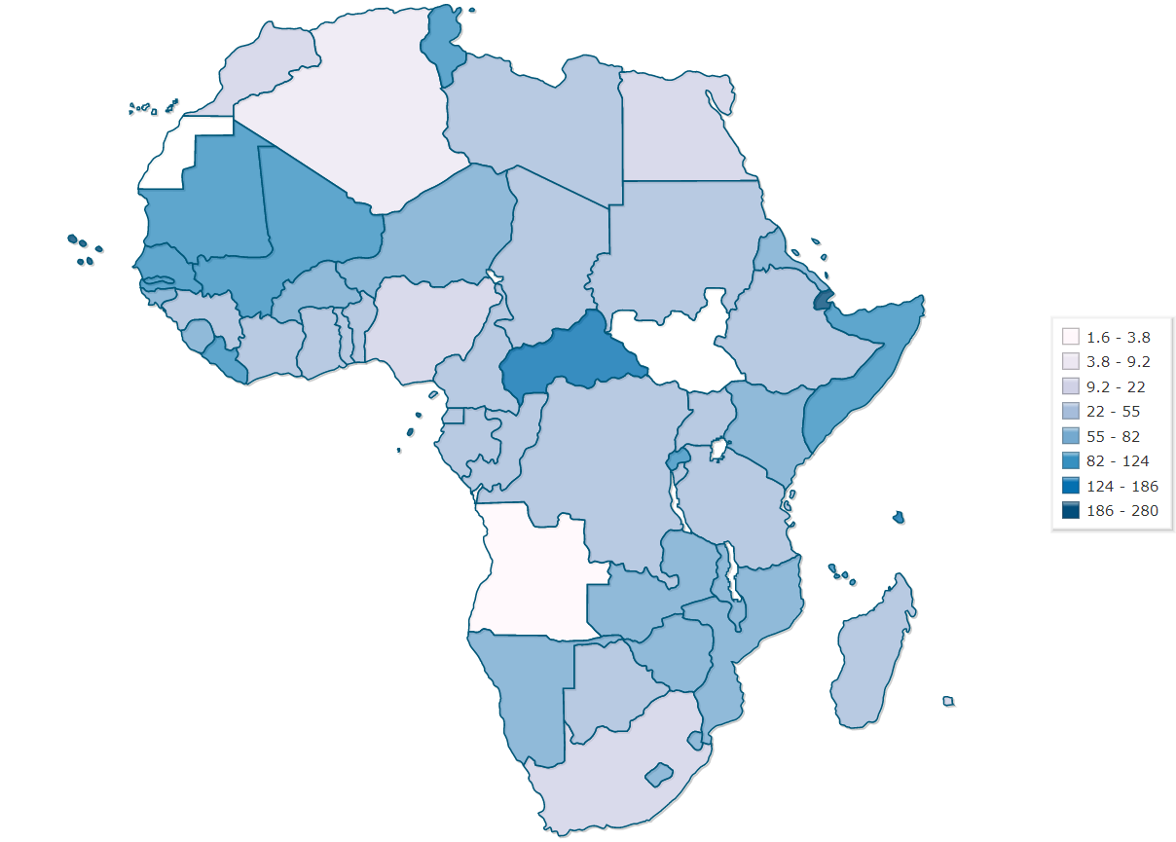

Eswatini

Lesotho

BotswajnaLes

Mozambique

Malawi

Zambia

South Africa

Namibia

Botswana

Zimbabwe

1. Donors’ requirements

Harare Office mostly mobilized resources from the governments of Nordic countries, EU and UN partnerships. Requirements of top 3 donors are as follows:

|  |  |  |
| --- | --- | --- |
| **Donor** | **Project** | **Main Donor requirements** |
| Sweden Government | Our Rights, Our Lives, Our Future | Annual result-based reports against the Result Assessment Framework; Annual workplans and budgets; annual certified financial reports; an external evaluation |
| EU | Skills and Technical Education Programme (STEP) | Tendering and Procurement should be governed by UNESCO rules;  Three monthly progress reports against Annual work plans indicators; Inception report and the Annual work plans; The final project report and evaluation report |
| Switzerland | Our Rights, Our Lives, Our Future PLUS | Annual operational reports; annual financial certified reports;  Final evaluation report |

1. Program management

With the minimal resources available, the Office aimed to ensure that all the programmes are in sync with SDGs, AU Agenda 2063, SADC and national priorities. Regular Programme funds will be catalytically positioned to attract extra-budgetary resources. Partnerships will be strengthened while enhancing visibility of UNESCO’s work will also be prioritised.

1. Programme portfolio

The table below represents 40 C/5.

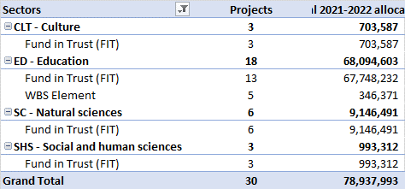

*Source: 40C/5 financial SISTER report*

The current project portfolio is as follows:

|  |  |  |  |  |  |
| --- | --- | --- | --- | --- | --- |
| **Budget code** | **Project title (full)** | **Sector** | **Contract type** | **Total Allocation per project** | **Donor** |
| 503RAF1001 | Our Rights, Our Lives, Our Future: Making positive sexual and reproductive health and education outcomes a reality for adolescents and young people in Sub-Saharan Africa | ED - Education | Fund in Trust (FIT) | 31 401 092 | Sweden Government |
| 549MLW1000 | Skills and Technical Education Programme (STEP) | ED - Education | Fund in Trust (FIT) | 10 055 860 | European Union |
| 503ZAM1001 | Our Rights, Our Lives, Our Future (O3) Zambia | ED - Education | Fund in Trust (FIT) | 8 296 324 | Sweden |
| 501RAF1002 | Our Rights, Our Lives, Our Future PLUS | ED - Education | Fund in Trust (FIT) | 7 613 771 | Government - Switzerland - Government of Switzerland |
|  | Strengthening local communities' adaptive capacity and resilience to climate change through sustainable groundwater exploitation in Zimbabwe | SC - Natural sciences | Fund in Trust (FIT) | 5 000 000 | #N/A |
| 504MLW1000 | Our Lives, Our Rights, Our Future Malawi | ED - Education | Fund in Trust (FIT) | 3 392 686 | NORWAY |
| 503RAF1002 | Advanced Regional Training Programme (ARTP) in Education for Sustainable Development (ESD) For ECCE, Primary and TVET Teacher Educators in Southern Africa | ED - Education | Fund in Trust (FIT) | 2 439 301 | Sweden |
| 547RAF1000 | "Our Rights, Our Lives, Our Future" - Irish Aid contribution | ED - Education | Fund in Trust (FIT) | 2 141 078 | Ireland Government |
| 513SAF2003 | Addressing Climate Risk and Building Adaptive Capacity in South Africa's Biosphere Reserves: Towards Sustainable Water and Ecosystem Management | SC - Natural sciences | Fund in Trust (FIT) | 1 743 133 | Government - Belgium - Government of Flanders |
| 268ZIM1000 | Spotlight Initiative to Eliminate Violence against women and girls in Zimbabwe | ED - Education | Fund in Trust (FIT) | 1 147 266 | MPTF UNDP |
| 531RAF2000 | A Community-focused Flood Early Warning System for the BuPuSa Transboundary River Basins | SC - Natural sciences | Fund in Trust (FIT) | 1 002 358 | Government - Austria - Austrian Development Agency |
| 513RAF2022 | BE-RESILIENT: Biosphere Reserves as Observatories for Climate Change Adaptation in Southern Africa | SC - Natural sciences | Fund in Trust (FIT) | 590 000 | FLANDERS |
| 216ZIM2000 | Comprehensive Resilience Building in the Chimanimani and Chipinge Districts of Zimbabwe | SC - Natural sciences | Fund in Trust (FIT) | 500 000 | UN - United Nations Office for Project Services |
| 261ZIM3001 | Strengthening Disability Rights Accountability, Governance and Coordination in Zimbabwe | SHS - Social and human sciences | Fund in Trust (FIT) | 370 000 | UN - UN Partnership on the Rights of Persons with Disabilities, UNPRPD |
| 218MLW1000 | Learning Never Stops Malawi | ED - Education | Fund in Trust (FIT) | 350 000 | UN - United Nations Fund for International Partnerships UNFIP |
| 504MLW4000 | Strengthening Institutional Capacities in Implementing the Malawi Cultural Policy in line with the UNESCO 2005 Convention on Cultural Diversity in Malawi | CLT - Culture | Fund in Trust (FIT) | 336 120 | Government - Norway - Ministry of Foreign Affairs |
| 261ZIM3000 | Advancing the Rights of Women and Girls with Disabilities in Zimbabwe | SHS - Social and human sciences | Fund in Trust (FIT) | 317 196 | UNPRPD - Disability Fund |
| 261RAF3000 | Ending Stigma and Discrimination, Breaking the Cycle of Poverty and Marginalization of Persons with Disabilities | SHS - Social and human sciences | Fund in Trust (FIT) | 306 116 | UN - UN Partnership on the Rights of Persons with Disabilities, UNPRPD |
| 201ZIM1001 | COVID-19 Accelerated Funding for the Education Sector in Zimbabwe | ED - Education | Fund in Trust (FIT) | 288 900 | UNICEF |
| 218ZIM1000 | Strengthening research capacity of MoPSE under TEACH Project in Zimbabwe | ED - Education | Fund in Trust (FIT) | 276 704 | UN - United Nations Children's Fund UNICEF |
| 263ZIM2000 | Catalysing Investments in Climate and Sustainable Energy for productive use and the Achievement of the SDGs in Zimbabwe | SC - Natural sciences | Fund in Trust (FIT) | 261 000 | Joint SDG Fund |
| 513RAF4013 | Culture, public spaces and sustainable cities - Southern Africa | CLT - Culture | Fund in Trust (FIT) | 250 000 | Government - Belgium - Government of Flanders |
| 501RAF1001 | Our Rights, Our Lives, Our Future PLUS Inception Phase | ED - Education | Fund in Trust (FIT) | 245 250 | SWITZERLAND |
| 257GLO1041.3 | UNAIDS Eastern & Southern Africa 2018-2019 Programme for HIV & Health Education | ED - Education | WBS Element | 137 986 | UNAIDS |
| 513RAF4011 | Strengthening sub-regional cooperation and national capacities in seven Southern African countries for implementing the 2003 Convention for the Safeguarding of the Intangible Cultural Heritage (2018) | CLT - Culture | Fund in Trust (FIT) | 117 467 | Government - Belgium - Government of Flanders |
| 570RAF1007 | Regional Campaign on preventing Early and Unintended Pregnancy | ED - Education | Fund in Trust (FIT) | 100 000 | David and Lucile Packard |
| 257GLO1043.3.16 | 257GLO1043.3.16 - ZIMBABWE (UNAIDS Country Envelope 2020-2021) | ED - Education | WBS Element | 80 187 | UNAIDS |
| 513RAF2021 | Needs assessment for Climate Services for improved Water Resources Management in vulnerable regions to Southern Africa | SC - Natural sciences | Fund in Trust (FIT) | 50 000 | Government - Belgium - Government of Flanders |
| 257GLO1040.3.6 | Malawi - UNAIDS Country Envelope | ED - Education | WBS Element | 47 170 | UNAIDS |
| 257GLO1043.3.3 | 257GLO1043.3.3 - Eswatini (UNAIDS Country Envelope 2020-2021) | ED - Education | WBS Element | 43 832 | UNAIDS |
| 257GLO1043.3.8 | 257GLO1043.3.8 - MALAWI (UNAIDS Country Envelope 2020-2021) | ED - Education | WBS Element | 37 196 | UNAIDS |
|  |  | Total |  | 78 937 993 |  |

The projects highlighted in yellow will be used for sampling.

1. Education regional programs

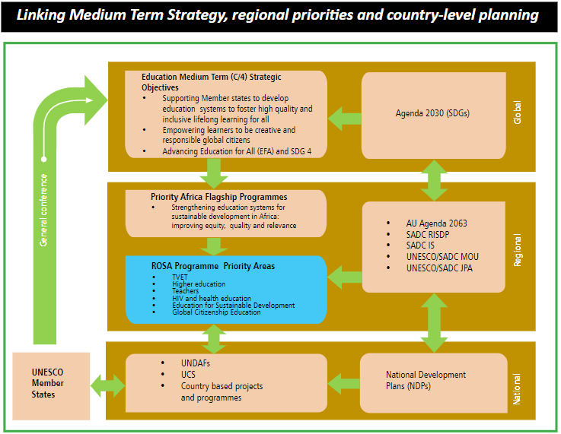

1. Natural Sciences regional programs

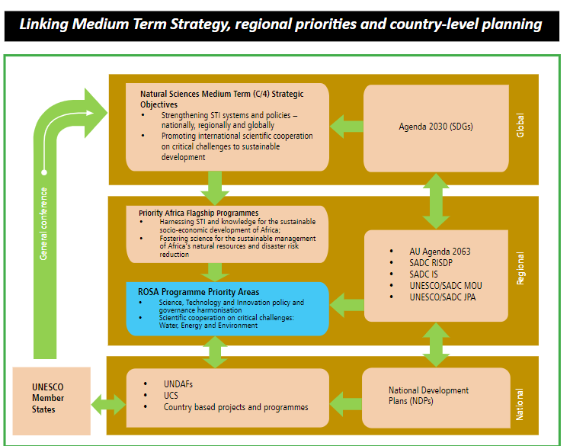

1. SHS regional programs

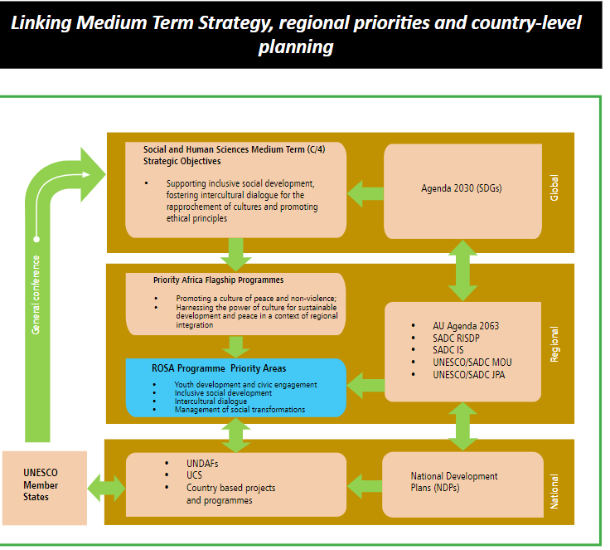

Observations:

* SHS in ROSA is quite new. Before 2016 there was no SHS component. It’s a young sector. It was extraordinary opportunity for the Office to seize opportunities.
* As of now, the largest programme is on social inclusion, particularly people with disabilities in Zimbabwe and in the region.
* Phinith will share the report with IOS. SHS was successful on second line, inclusive development.

1. Culture regional programs

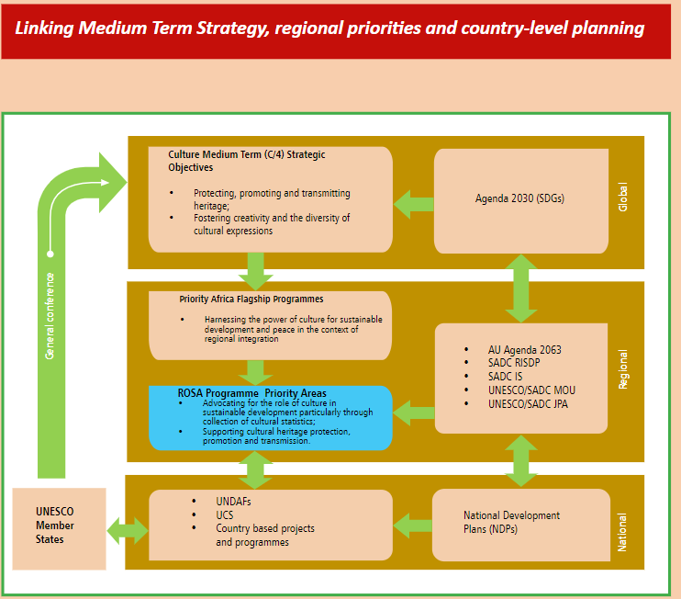

1. CI regional programs

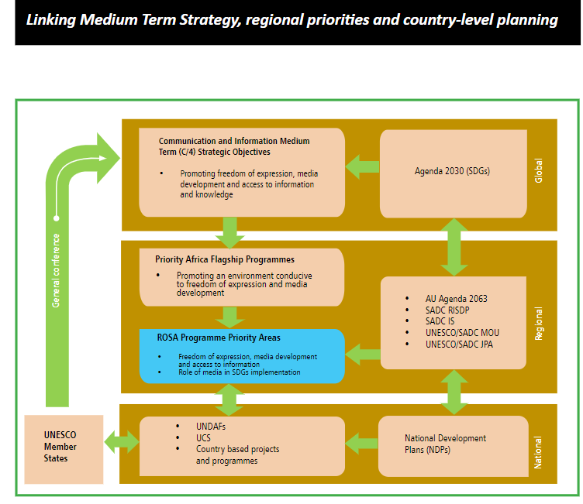

* CI decentralized around 150 K USD for 41 C/5 (RP) to Harare.

|  |
| --- |
| PARTNERSHIPS |

1. UNESCO Chairs and Category 2 Centers

* There are 19 UNESCO Chairs in the region as shown in the table below.

|  |  |  |
| --- | --- | --- |
| Nr | Country | Chair |
| 1 | Zimbabwe | UNESCO Chair on African Heritage (2020) The Great Zimbabwe University (1431) |
| 2 | Zambia | UNESCO Chair in Renewable Energy and Environment (2001), University of Zambia, Lusaka (524) |
| 3 | South Africa | UNESCO «Oliver Tambo» Chair of Human Rights (1996), University of Fort Hare, Alice (211) |
| 4 | South Africa | UNESCO Chair in Geohydrology (1999), University of the Western Cape, Bellville (426) |
| 5 | South Africa | UNESCO Chair in Values Education-Learning to Live Together (2005), University of Johannesburg (678) |
| 6 | South Africa | UNESCO Chair in teacher education for diversity and development (2009), University of the Witwatersrand, Johannesburg (852) |
| 7 | South Africa | UNESCO Chair in Education Law (2010), University of Pretoria (914) |
| 8 | South Africa | UNESCO Chair in Nanosciences and Nanotechnology (2015), The University of South Africa and The Nanosciences African Network NANOAFNET (1098) |
| 9 | South Africa | UNESCO Chair on Community Media (2017), University of Limpopo, Sovenga (1223) |
| 10 | South Africa | UNESCO Chair on African Food Systems (2017), University of the Western Cape (1244) |
| 11 | South Africa | UNESCO Chair on Open Distance Learning (2018), University of South Africa, Pretoria (1257) |
| 12 | South Africa | UNESCO Chair on Cultural Policy and Sustainable Development (2019), Tshwane University of Technology, Pretoria (1321) |
| 13 | South Africa | UNESCO Chair on Multimodal Learning and Open Educational Resources (2019), North-West University, Potchefstroom (1344) |
| 14 | South Africa | UNESCO Chair on African Integration and Innovation (2021), Tshwane University of Technology, Pretoria (1454) |
| 15 | South Africa | UNESCO Chair on Open Education and Social Justice (2021), the University of Cape Town (1480) |
| 16 | South Africa | UNESCO Chair on Complex Systems and Transformative African Futures (2022), The Stellenbosch University (1518) |
| 17 | Namibia | UNESCO Chair on Sustainable Water Research for Climate Adaptation in Arid Environments (2017), Namibia University of Science and Technology (1217) |
| 18 | Namibia | UNESCO Chair on Gender and Digital Technologies (2020), Namibia University of Science and Technology (1427) |
| 19 | Botswana | UNESCO Chair on "African Heritage Studies and Sustainable Development" (2020), University of Botswana (1440) |

1. Network and partnership strategy The office coordinates its activities with various programmatic partners in the region.

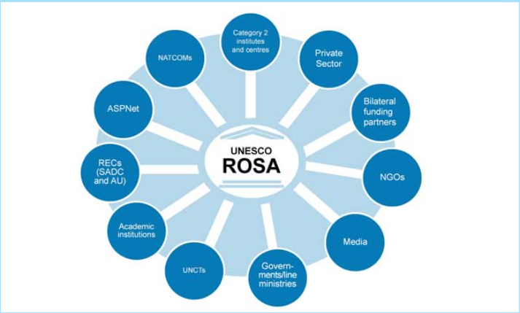

1. UNESCO-SADC (Southern African Development Community) Joint Programme of Action

The UNESCO Regional Office for Southern Africa also serves as the Organisation’s focal point for cooperation with the Southern African Development Community (SADC) and Common Market for Eastern and Southern Africa (COMESA). The major strategic objectives of the partnerships shall be to:

* strengthen the scope, outreach, visibility, results, delivery and impact of ROSA’s programmatic objectives and priorities in accordance with the C/4 and C/5 documents;
* increase funding and other resources from the various partners in a more organised, innovative and sustainable manner;
* create alliances within the frameworks approved by Member States;
* raise awareness and mobilise public support for • priority issues; and influence political and civil society agendas
* ROSA will work closely with the NATCOMs to ensure effective delivery of UNESCO programmes. In this regard, consultative meetings with NATCOMs will be held annually to plan together and report on progress. The NATCOMs will also partner with ROSA in implementing activities in their respective countries.

With the nine countries covered all being SADC members, this Strategy also takes into account the aspirations of the regional block. To this end, UNESCO ROSA and SADC have developed a new Framework Agreement for Cooperation and a Joint Programme of Action. This cooperation focuses on eight priority areas, namely: education; HIV and health education; science, technology and innovation; water security, renewable energy and disaster risk management; social and human sciences; culture; communication and information; and data for development.

The current SADC-UNESCO Joint Programme of Action (JPA) 2017-2021 provided eight concrete areas of cooperation, including Education and Skills Development; Education for Health and Well-being; Science, Technology, and Innovation (STI); Water Security, Renewable Energy, and Disaster Risk Management; Social and Human Sciences; Culture; Communication and Information; and Data for Development.

Currently, UNESCO Harare and SADC are finalizing JPA 2022-2025. Both UNESCO’s and SADC’s strategic frameworks have prioritized gender equality and women’s empowerment as a fundamental human right and an important factor in sustainable development, and have critical instruments affirming its importance.

National commissions in the region are active, i.e., German commission organized some activities with Harare Office.

1. Leadership composition and organigram

*Staff’s background*

**Head of Office**

* The new Director came on board in January 2022. Lidia was nominated as at December 2021.
* Hubert, former Harare Dir, was OIC for Harare from Jul to Dec 2021. He took functions in Nairobi earlier in 2021 since he got a country clearance quickly. Hubert was Harare Director between 2013 and 2021.
* Hubert oversaw national offices. It was working very well. Namibia (Windhoek) and Mozambique (Maputo) report to Harare, and their respective Heads are assessed by DIR/HAR.
* That being said, the majority of the period under audit was managed and controlled by Prof Hubert Gijzen and Ms Su Ya, the former Regional Director and Finance and Administrative Officer (AO) respectively. I assumed the Regional Director role on 1 December, 2021 (remotely) and arrived in Harare on the 6 January, 2022 and the current AO, Ms. Dawn Clemitson, joined the Office effective 1 July 2021.

Administrative Unit

BFM has alerted the Office to some Administrative Assistants postings where their authorization level was exceeded. This has been addressed and transactions reversed and reposted where possible. The Administrative Assistants explained that these instances were not intentional but were errors that had occurred and often attributed to a lapse in concentration when processing high numbers of transactions, and challenges during the initial start of telecommuting.

1. Ethical conduct

The Ethics Office undertook a mission to the Harare Office in May 2019 in order to conduct training on ethics and anti-harassment. An ethical case is about the alleged harassing behaviour of a staff member in the office.



1. Budget

**REGULAR PROGRAMME BUDGET**

The Office has the following RP budget for 40 C/5 and 41 C/5. Overall, the biggest chunk of budget is dedicated to staff costs. Budgets for Programme Sectors and Office running costs are at the same level.

**40 C/5 and 41 C/5 Budget breakdown**

|  |  |  |  |  |  |  |
| --- | --- | --- | --- | --- | --- | --- |
|  | **40 C/5** | | | **41 C/5** | | |
| **Sector** | **Count of Fund** | **Sum of Allocation** | **%** | **Count of Fund** | **Sum of Allocation** | **%** |
| Staff costs | 10 | 4 886 755 | 64% | 14 | 4 840 622 | 68% |
| FSC - Field Office Running Costs | 12 | 1 265 645 | 17% | 9 | 1 141 394 | 16% |
| ED - Education | 16 | 440 624 | 6% | 15 | 338 792 | 5% |
| SC - Natural Sciences | 14 | 407 858 | 5% | 9 | 222 543 | 3% |
| SHS - Social and Human Sciences | 8 | 301 134 | 4% | 6 | 174 321 | 2% |
| CLT - Culture | 15 | 176 931 | 2% | 14 | 227 353 | 3% |
| CI - Communication | 9 | 150 203 | 2% | 8 | 150 974 | 2% |
| **Grand Total** | **84** | **7 629 149** | **100%** | **75** | **7 095 999** | **100%** |

*Source: YFM1 report 2020-2023*

|  |  |  |  |  |
| --- | --- | --- | --- | --- |
| Budget item | 2020-2021, 40 C/5 | Percentage | 2022-2023, 41 C/5 | Percentage |
| Staff costs | 4 886 755 | 64% | 4 840 622 | 68% |
| Field Office Running Costs | 1 265 645 | 17% | 1 141 394 | 16% |
| Programme Sectors | 1 476 750 | 19% | 1 113 983 | 16% |
| Total | **7 629 149** | **100%** | **7 095 999** | **100%** |

**VOLUNTARY CONTRIBUTION BUDGET**

The Office received a total of USD 33 M from different donors during 40 C/5, 2020-2021.

|  |  |  |  |  |  |
| --- | --- | --- | --- | --- | --- |
| Fund | Sector | Project text | Status | Donor | Total allocation |
| 503RAF1001 | ED | Our Rights, Our Lives, Our Future: Makin | REL | Sweden Government | 15 461 346 |
| 549MLW1000 | ED | Skills and Technical Education Programm | TECO | European Union | 4 575 820 |
| 503ZAM1001 | ED | Our Rights, Our Lives, Our Future (O3) Z | REL | Sweden | 3 996 981 |
| 504MLW1000 | ED | Our Lives, Our Rights, Our Future Malawi | REL | NORWAY | 1 986 949 |
| 503RAF1002 | ED | Advanced Regional Training Programme (AR | REL | Sweden | 1 769 271 |
| 547RAF1000 | ED | "Our Rights, Our Lives, Our Future" - Ir | REL | Ireland Government | 1 537 309 |
| 268ZIM1000 | ED | Spotlight Initiative to Eliminate Violen | REL | MPTF UNDP | 636 561 |
| 513SAF2003 | SC | Addressing Climate Risk and Building Ada | REL | FLANDERS | 498 398 |
| 216ZIM2000 | SC | Comprehensive Resilience Building in the | REL | (blank) | 462 963 |
| 513RAF2022 | SC | B-RESILIENT: Biosphere Reserves as Obser | REL | FLANDERS | 402 317 |
| 501RAF1002 | ED | Our Rights, Our Lives, Our Future PLUS | REL | SWITZERLAND | 366 644 |
| 263ZIM2000 | SC | Catalysing Investments in Climate and Su | TECO | Joint SDG Fund | 321 467 |
| 201ZIM1001 | ED | COVID-19 Accelerated Funding for the Edu | REL | UNICEF | 305 931 |
| 501RAF1001 | ED | Our Rights, Our Lives, Our Future PLUS I | CLSD | SWITZERLAND | 229 293 |
| 261ZIM3000 | SHS | Advancing the Rights of Women and Girls | TECO | UNPRPD - Disability Fund | 205 888 |
| 261RAF3000 | SHS | Ending Stigma and Discrimination,Breakin | REL | UNPRPD - Disability Fund | 198 090 |
| 504MLW4000 | CLT | Strengthening Institutional Capacities i | REL | NORWAY | 104 340 |
| 261ZIM3001 | SHS | UNPRPD Inception Phase 4th Funding Round | REL | UNPRPD - Disability Fund | 65 421 |
| 570RAF1007 | ED | Regional Campaign on preventing Early a | CLSD | David and Lucile Packard | 20 374 |
| 218ZIM1000 | ED | Strengthening research in the Ministry o | REL | UNICEF | 7 492 |
| 218MLW1000 | ED | Learning Never Stops Malawi | TECO | MPTF | 1 |
| 531RAF2000 | SC | A Community-focused Flood Early Warning | REL | Austra | 1 |
| Grand Total |  |  |  |  | 33 152 856 |

*Source: YPS8 report 2020-2021*

Sector-wise the 2020-2021 budget breakdown is as follows. No ExB projects in CI sector.

|  |  |
| --- | --- |
| Sectors | Total allocation |
| ED | 30 893 971 |
| SC | 1 685 145 |
| SHS | 469 399 |
| CLT | 104 340 |
| Grand Total | **33 152 856** |

**EXPENDITURES**

The Office total expenditures between January 2020 to Mar 2022 (audit period) totals to USD 19 million excluding salaries for regular staff, PAs and service contract holders.

|  |  |  |
| --- | --- | --- |
| **Expenditure Type** | **Total** | **Percentage** |
| ZPOLIST (commitments made by the office) | 15 293 946 | 82% |
| Business trip commitments of staff (All Postings) | 633 512 | 3% |
| Fund reservations (All Postings) | 2 625 784 | 14% |
| **Total** | 18 553 242 | 100% |

*Source: ZPO List, All postings report, 01012020-31032022*

The biggest risk in payments lies down in Funds Reservations as there are less in-built controls in managing commitments by default.

1. Contracting and procurement:

Despite a significant high contract and procurement activity of 15$ Million, the Office does not have a procurement plan.

**Expenses by commitment type for the period (2020-2022)**



* *Source: ZPO list, Harare materials groups*

Contract for services represent 76% and should be tested as part of field work.

**Top 10 Vendors**

The cumulative contract amount of top 10 vendors amounts to USD 2,809,540 representing 18% of the total expense 15 293 946.



*Source: ZPO list, Harare materials groups*

**Contracting:**

CMT profile of the Office during the audit period is as follows:



* In terms of procurement method, the Office mainly uses RFP and RFQ. However, 30% of procurement belongs to IPAs and Individual consultants who are not subject to selection of procurement method. Hence the testing should cover both.



**Contract sampling**

IOS used the following methodology:

* Selected procurement methods with highest volumes, i.e. contracts for individual consultants, IPAs, RFP and RFQ.
* Further, judgmentally sampled contracts taking into account the following factors:
  + USD amount of a contract
  + Recurrence of vendors
  + Repeated contracts for one vendor, one after another, with accumulative contract amount >150K requiring CC
  + Waivers for a selection method
  + Bad rating of a vendor in CMT
  + Advance payment granted to a vendor within a contract framework
* As a result, IOS sampled 63 contracts of 36 vendors for substantive testing. The sample amounts to 3 752 076 USD, representing 23% out of the total volume of 16 000 372.



**Main points discussed with ADM/PRO:**

* Exchanges with Harare are pretty limited which is strange given very high programme portfolio (US$ M) and the Office does not submit contracting proposals to the CC. Usually, contracts are less than 50K and procurement office is not fully aware if this is done on purpose.
* For contracts between 50 and 150K, formal procurement should be done, i.e. use of formal RFP forms, proven confidentiality of bids receipt, independent evaluation of bids, publishing on UNGM is strongly recommended.
* Rhodes University, IPA, was one of the biggest contracts for Harare. Eero did not recall the details of the file but he had an impression that there was no other choice than this university (fait accompli).
* As for Eero, having Harare AO who processes all the contracts outside of Harare is not a perfect structure – it adds on delays, confusions etc. It is not effective as the AO in Zimbabwe simply lacks on-site information, context and is overwhelmed with tasks related to Harare Office itself.
* There were some discussions on UN collaborations, incl. travel agency. Su Ya was leading on that. Usually, UN LTAs are fine and don’t have any issues.

1. Travel

The total amount of business trips during the audit period includes an expense of $ 633 512 covering 1327 business trips

* Travel Data indicates that the Office’s staff travelled significantly before the COVID pandemic notably the Head of Office and the SHS programme specialist.
* Travelers have faced challenges submitting travel requests timely: A number of requests require derogation relating to the Administrative Manual Travel Chapter that requires submission of travel requests at least 14 days before travel commences. The late submission is often attributed to partners having to obtain authorization for meetings conferences etc. in the context of the evolving COVID-19 sanitary situation and moving forward with short notice.
* Since new Director’s arrival, travellers are encouraged to enter their intended travel in DUO Travel as soon as they are aware and rather request cancellation of the request if the partner subsequently changes dates or cancels.
* During the audit period there were 187 missions, 50 of them (27%) were planned late, hence, require derogation for purchase of tickets less than 14 days.

**Highest derogations**

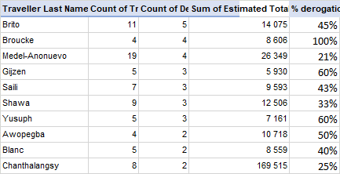

**Top travellers**

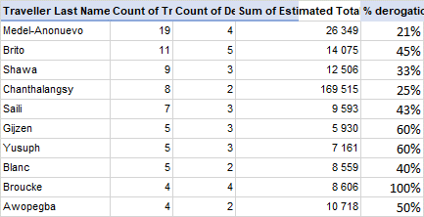

|  |
| --- |
| RISK MANAGEMENT |

The Office assesses that its internal controls area globally under control.

**Results of the 2020 Control Self-Assessment**

|  |  |  |
| --- | --- | --- |
| Functional Area | Self-Assessment (2020) | IOS Comments |
| Strategic framework, risk and control environment | Globally under control | The Office established too many frameworks |
| Programme Management | Globally under control | Issues observed with signatory of Donors’ agreements without proper consultations with HQ |
| Financial Control | Globally under control | Potential risk of fraud given hyperinflation and unstable economic environment |
| Procurement and contracting | Globally under control |  |
| Human Resources Management | Globally under control |  |
| Travel Management | Globally under control | Missions planned last minute |

*Source: CSA2020_Global ratings*

**Medium and high residual risks from the risk register**

|  |  |  |  |  |  |  |
| --- | --- | --- | --- | --- | --- | --- |
| Nr | Risk short name | Risk description | Impact | Likeli-hood | Overall risk rating | Risk treatment / mitigation |
| 1 | Accountability | Failure to establish and disseminate a clear accountability framework that achieves the right balance between centralization and decentralization (including true delegation of authority to the field) leads to bottlenecks in decision-making and impacts the Office ability to meet UNESCO's strategic goals  Opportunity: To develop more transversal projects that leverage on successful projects in other Offices and or Regions | 4-Significant | 3-Possible | Medium High | Establish open communication at level of Directors/ Heads of Office, Head of Units level to promote information sharing and joint actions / Internal PS discussions with invitation extended to HoO for the region to establish a common understanding of country and regional initiatives  INSERT IN OFFICE OBJECTIVES |
| 2 | Host Country Environment | Dramatic changes in the socioeconomic or political environment, fiscal and monetary policies or a decline in the sanitary (health) situation  Opportunity: Economic and political events opening different areas for cooperation and strengthening alignment between UNESCO mandate and Government policies | 5-Severe | 5-Very likely | High | Increased advocacy and lobbing of influential people/organizations in country to publicly express support for UNESCO projects; Active participation in UNCT and Government briefings on policies; UNCT participants to contribute to the discussion to explore options for addressing impact of policy changes / planned disinvestment; Update work plans so that they are in line with changes in Member States' policies and institutional setups and priorities and adjust the activities of the Office to these changes; UNESCO contributes towards joint UN initiatives to provide some level of care in respect of COVID; Flexible working arrangements to allow Staff and Personnel to telecommute if they feel uncomfortable with coming to the office or if they suspect that they may be infected |
| 3 | Organizational transformation | Failure to initiate, integrate and execute changes deriving/stemming from Organization/strategic transformations and reforms | 4-Significant | 3-Possible | Medium High | Recruit a dedicated communications officer to focus on planning of communication and messages communicate UNESCO's priorities and achievements; Active participation in UNCT; Integration of UN reform processes and contents in organizational discussions and meetings at all levels  WHAT STRATEGIC CHANGES DOES THE OFFICE WANT TO MAKE? IF YES, WHO WOULD LEAD THIS CHANGE EFFORT? THE  COMMUNICATIONS OFFICE WOULD SUPPORT BUT MAY NOT LEAD THIS CHANGE? |
| 4 | Project managament | Poor procurement planning and unrealistic timeline for PA and other temp personnel selection, not following up on receipt and quality of deliverables on a timely basis and of payment delays because of slow sign off by bank signatories results in loss of credibility with contractors, donors, partners and senior management at HQ | 3-Moderate | 3-Possible | Medium | Procurement Plan prepared by beginning of the biennium and updates as an when new project funding is mobilized; Bi-weekly reports on project implementation from AO unit to Director and Programme Specialists reporting on implementation rate of RP and EXB projects; Fortnightly Director and Programme Heads of Unit and AO meeting to discuss programmatic developments, upcoming missions and new resource mobilization opportunities and initiatives; AO Unit to offer training to programme staff and personnel on selected aspects of the Administrative and Human Resource Manual, and also one on one coaching as and when requests are rejected; Office to petition ADM to review the AO Unit staffing and grading |
| 5 | Exponential Office growth | The Office financial and programmtic control framework is stretched and can fail | 3-Moderate | 3-Possible | Medium | HRM HAR to establish a formal induction programme which can be followed remotely via MS teams, which gives newly recruited staff and personnel an overview of UNESCO's regulations and rules; HRM HAR to establish a list of all mandatory UNESCO training maintain a listing of all staff and personnel who have successfully completed the trainings |

The Office pointed out themselves an exponential growth of financial and programmatic portfolio and associated risks such as a big challenge to deliver.

1. Prior external assurance reports

IOS previously did a remote audit in 2015. It contained 5 recommendations, all of them were verified and closed:

**Recommendation 1**: The Office to reiterate to all personnel the mandatory requirement to respect UNESCO’s IT Security Policy and Guidelines, in particular those relating to Access Codes and Password Policy, noting that future instances may lead to disciplinary measures as provided in the policy. Passwords should be re-set for any personnel having engaged in sharing.

**Recommendation 2**: The Office to introduce procedures and clearly assign accountability for the timely recovery of Value Added Taxes and give priority to recovering all unclaimed amounts for the past three years.

**Recommendation 3**: The Office to (a) in consultation with the BFM, organise training to be presented by the Administrative Officer on the UNESCO policy for selection of contractors for all personnel involved in the contracting process and (b) ensure that relevant policy for selection of contractors is followed before certifying the contracts.

**Recommendation 4**: The Director of the Office, in consultation with HRM, to review and revise the job descriptions of staff where needed to align with current roles and priorities of the Office.

**Recommendation 5**: The Office to (a) establish a check list for travel to ensure that travel orders are complete, in compliance with the policy and issued timely and that travel records are accurately processed and (b) recover the overpayment of US $2,115 from the travellers concerned, as indicated in the Annex III.

|  |
| --- |
| CONTROL ACTIVITIES |

1. Payment Process in SAP

The Office doesn’t pay with cheques, neither cashable nor payee cheque.

* Purchase orders: The creation of the purchase order in SAP lies on the dual validation from certifying officer and director. The dual control validation is embedded in the system for Purchase Orders payment through automated SOD for the creation of PO and MIRO (Good Receipt) transaction in SAP.



The key controls in this workflow are the following:

* Segregation of duties between the PO creation and PO release
* Verification of good receipts before doing the SES
* Segregation of duties between MIRO and outgoing payment posting but SOD in the previous flow should be sufficient.
* Fund Reservation: The creation of fund reservation involves the administration unit only and should be used for exceptional circumstances, often for staff insurance, small purchases, etc.

The key control in this flow is the **independent verification** of the invoice posting through supporting documentation for justification between FB60 and F-53.

In SAP, Field offices can make payment, through (i) Headquarters for high amounts in USD (using the Ref key 2), (ii) the local bank accounts in USD or local currency for transfers or cash and cheques.

The Administrative unit indicated that the Office does not use cheques and little cash, which last was for the Officer-in-Charge’s DSAs.

**Control weakness**:

The Office operates in an environment that is characterized by hyperinflation and a subculture exists whereby costs can be inflated. The AO and team do monitor this closely and have taken steps to diversify suppliers to discourage a dependency relationship being built especially for standard goods and services e.g., catering.

Scanning of purchase data indicate cross-charging at the end of the year.

1. Harare Unliquidated Obligations as of April 2022

No FRs aged more than 6 months

**Goods received not invoiced**

All 11 entries need to be followed up and reasons for not invoicing (>6 months) need to be clarified



**Purchase orders**

36 POs are not liquidated for more than 6 months, this needs to be carefully followed up.

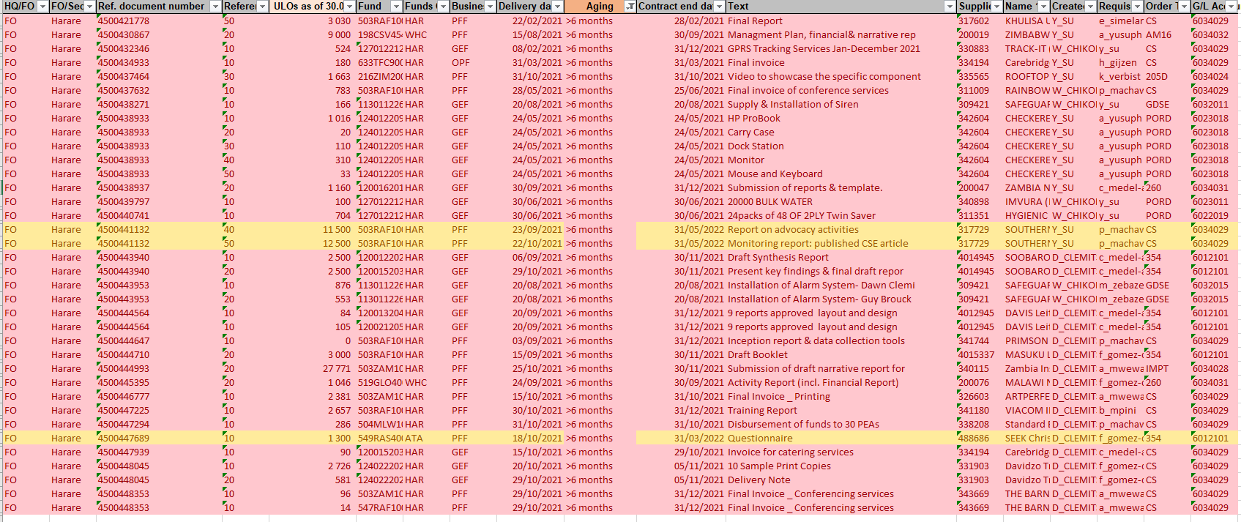

**Travel missions**

13 travel missions were not cleared, aging between 2 and 6 months. To be followed up as well.

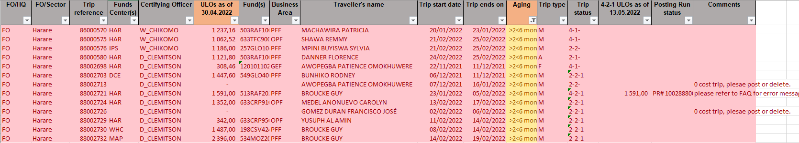

1. Payment profile in terms of currency



* The Office does not make any payments using cheques.
* The UNESCO Office in Harare is banking with Standard Charted Bank.



* Sample on-site reconciliation between banking tool and SAP

1. Banking

* There is an Antenna in Lusaka, and at the request of the former AO requested, UNESCO opened two additional accounts in Lusaka, Zambia (in USD and ZMW, Kwacha, local Zambian currency).
* The Office also makes payments in South Africa in local south African currency (via UNDP). The current AO made a request to open a bank account in South Africa, however, Treasury is not going to opt for it as the volume of operations in South Africa is low. An alternative for UNDP payment process which is lengthy and costly, could be Worldlink by Citibank. It is a relatively easy solution and less expensive, it would involve only currency conversion, from USD to local currency.
* UNESCO treasury was not informed about any banking issue in Harare.
* Overall, nowadays, banks ask more and more questions when an entity wants to change  bank signatories. Sometimes UNESCO Offices have to give copies of UNLPs, residency cards etc.  The Director and AO complained that the local bank has not yet updated their names in the bank signatory records, despite HQ instructions.
* SCB will be leaving 7 countries in Africa, i.e. Zimbabwe, Cameroon, Jordan, Tanzania (only retailing). They are concentrating on global, emerging markets. In case of Zimbabwe, there is Ecobank and it would be a good option. UNESCO treasury would await UNCT recommendation and then decide.
* The AO in Harare is overall responsible for Lusaka accounts. She does bank reconciliation for Lusaka and Harare accounts. Like Harare, UNESCO bank signatory list with the actual bank records needs to be verified in Lusaka.
* Harare Office doesn’t receive any replenishments locally, otherwise they would notice it through the system. There might be some small local funds coming in, that HQ is not aware of.
* The hyperinflation is there. UNORE rate is close to the official exchange rate. Anssi is aware of black-market rates that are very different from official ones. Staff are not authorized to go through it. Anssi is not aware of any solution with electronic currency.
* Treasury confirms the existence of an issue with bank details of vendors:
  + There is no link between SAP and online banking tool, hence, staff in FO can update vendor details themselves without any control.
  + If a payment is made via cheque, then there is no vendor behind.
  + The only solution – to implement a general banking module in SAP for FOs using SWIFT and making all payments within SAP. It is a big project and will require a lot of resources.
* Staff using mobile payments for payment of DSA of participants to meetings. This practice is considered safe by BFM/TRS.

BFM advised IOS to look at how the Office operates in the Lusaka Antenna, i.e., how the AO supervises and what she delegates.

UNESCO’s treasurer assisted the office in opening the Lusaka bank accounts to facilitate the project implementation. It could be useful if the audit reviewed whether opening a bank account in South Africa could bring cost reductions and speed up payments. South Africa has good flight connections when COVID does not disrupt air travel and is often the venue for UNESCO hosted meetings and conferences.

* **Does the Office have intermediary banks?**

1. VAT

**VAT account not systematically cleared:** The Office submits VAT refunds regularly however the Zimbabwe Revenue Authority issues refunds irregular. Currently the VAT account has a backlog of refunds received but has not allocated them to the relevant budget codes. This is work-in-progress however some refunds were so delayed that the budget codes have already been closed in prior biennia.

1. Vendor management process

* **SAP vendor creation**: perform a walkthrough at the Office on site
* **Local bank vendor creation**: For the local bank vendors, outside of SAP and not reconciled with SAP, the office pulls a PDF form from the bank website and input vendor bank information manually to be printed out as bank transfer form. This information is automatically stored in the bank form for future bank transfers. The form is signed by two bank signatories when there is bank transfer letter. They verify that the bank account details match the vendors’ check (equivalent to a bank official record), where the vendor’s name and bank account details appear.

1. Roles in Contract Management Tool / SAP (as currently released)

The roles in DUO CMT are adequate with the staff’s posts and respect the segregation of duties. All roles were attributed on need-to-know basis. No external staff (outside of Harare and/or relevant HQ central services) were identified.

|  |  |  |  |  |  |  |  |  |  |  |  |
| --- | --- | --- | --- | --- | --- | --- | --- | --- | --- | --- | --- |
|  | MembershipStatusToday | Released |  |  |  |  |  |  |  |  |  |
|  |  |  |  |  |  |  |  |  |  |  |  |
|  | **Count of EmployeeLogonName** |  |  | **Year validity** |  |  |  |  |  |  |  |
| **Unesdir Role** | **EmployeeName** | **RoleName** | **Membership Limit Amount** | **2014** | **2015** | **2017** | **2019** | **2020** | **2021** | **2022** | **Grand Total** |
| Programme Specialist, ED | **Awopegba, Patience** | **PROGRAMME_SPECIALIST** | (blank) |  |  | 1 |  |  |  |  | 1 |
| Finance Assistant | **Bandasi, Jacqueline** | **CERTIFYING** | 10 000 |  |  |  |  |  |  | 1 | 1 |
| ADM/ADS | **Bidault, Isabelle** | **CERTIFYING** | 150 000 |  |  |  |  |  | 1 |  | 1 |
| Director | **Brito, Lidia** | **APPROVING** | (blank) |  |  |  |  |  | 1 |  | 1 |
|  |  | **OFFICER_IN_CHARGE** | (blank) |  |  |  |  |  | 1 |  | 1 |
|  |  | **SUPERVISOR** | (blank) |  |  |  |  |  |  | 1 | 1 |
| Programme Specialist | **Broucke, Guy** | **SUPERVISOR** | (blank) |  |  |  |  | 1 |  |  | 1 |
| Programme Specialist | **Chanthalangsy, Phinith** | **APPROVING** | (blank) |  |  |  | 1 |  |  |  | 1 |
|  |  | **BANK_SIGNATORY** | (blank) |  |  |  | 1 |  |  |  | 1 |
|  |  | **SUPERVISOR** | (blank) |  |  |  | 1 |  |  |  | 1 |
| Senior Admin Assistant | **Chikomo, Willard** | **CERTIFYING** | 100 000 |  |  |  |  |  | 1 |  | 1 |
| AO | **Clemitson, Dawn** | **BANK_SIGNATORY** | (blank) |  |  |  |  |  | 1 |  | 1 |
|  |  | **CERTIFYING** | (blank) |  |  |  |  |  | 1 |  | 1 |
|  |  | **SUPERVISOR** | (blank) |  |  |  |  |  | 1 |  | 1 |
| ADM/ADS | **Edjigayehu-Grandclaude, Mekdes** | **CERTIFYING** | (blank) | 1 |  |  |  |  |  |  | 1 |
| Programme Specialist | **Gómez Durán, Francisco** | **BANK_SIGNATORY** | (blank) |  |  |  |  |  | 1 |  | 1 |
| Administrative Clerk | **Gota, Nancy** | **CERTIFYING** | 20 000 | 1 |  |  |  |  |  |  | 1 |
| HIV/ AIDS Officer | **Halimani, Lucas** | **BANK_SIGNATORY** | 20 000 |  |  | 1 |  |  |  |  | 1 |
| ADM/ADS | **Lara, Alma** | **CERTIFYING** | (blank) |  |  |  |  |  | 1 |  | 1 |
| Senior Project Officer | **Machawira, Patricia** | **SUPERVISOR** | (blank) |  | 1 |  |  |  |  |  | 1 |
| Senior Project Officer | **Medel-Anonuevo, Carolyn** | **SUPERVISOR** | (blank) |  | 1 |  |  |  |  |  | 1 |
| NATIONAL PROFESSIONAL OFFICER | **Mukabeta, Moses Tapfumaneyi** | **PROGRAMME_SPECIALIST** | (blank) |  |  | 1 |  |  |  |  | 1 |
| Finance Assistant | **Munanga Makore, Day** | **CERTIFYING** | 100 000 |  |  |  |  |  |  | 1 | 1 |
| Programme Assistant | **Musindo, Ruth** | **CLERK** | (blank) |  |  |  |  |  |  | 1 | 1 |
| CI Advisor | **Yusuph, Al Amin** | **BANK_SIGNATORY** | (blank) |  |  |  | 1 |  |  |  | 1 |
|  |  | **SUPERVISOR** | (blank) |  |  |  | 1 |  |  |  | 1 |
| Senior Programme Specialist | **Zebaze Kana, Martiale** | **BANK_SIGNATORY** | (blank) |  |  |  | 1 |  |  |  | 1 |
|  |  | **SUPERVISOR** | (blank) |  |  |  |  |  | 1 |  | 1 |
|  | **Grand Total** |  |  | **2** | **2** | **3** | **6** | **1** | **10** | **4** | **28** |

With regard to bank signatories in Harare, no anomalies were identified. One staff member, Medel-Anonuevo, Carolyn, has recently retired, as of 31 May 2022 and needs to be removed from signatory list shortly. To be put in a management letter. It should be also noted that one staff, Halimani, Lucas, has a limit for authorizing bank payments. NB need to test payments authorized by the staff. However, at present, neither the director nor the AO are bank signatories. There is unnecessary dependency on certain staff.

|  |  |  |  |  |  |  |  |  |
| --- | --- | --- | --- | --- | --- | --- | --- | --- |
| RoleName | BANK_SIGNATORY |  |  |  |  |  |  |  |
|  |  |  |  |  |  |  |  |  |
| **Count of EmployeeLogonName** |  |  | **Year validity** |  |  |  |  |  |
| **EmployeeName** | **MembershipStatus Today** | **Membership Limit Amount** | **2017** | **2019** | **2020** | **2021** | **2022** | **Grand Total** |
| **Chanthalangsy, Phinith** | **Released** | (blank) |  | 1 |  |  |  | 1 |
| **Clemitson, Dawn** | **Released** | (blank) |  |  |  | 1 |  | 1 |
| **Dijakovic, Damir** | **Disabled** | (blank) | 1 |  | 1 |  |  | 2 |
| **Gijzen, Hubert** | **Disabled** | (blank) | 1 |  |  |  |  | 1 |
|  | **Expired** | (blank) |  |  |  |  | 1 | 1 |
| **Gómez Durán, Francisco** | **Released** | (blank) |  |  |  | 1 |  | 1 |
| **Halimani, Lucas** | **Released** | 20000 | 1 |  |  |  |  | 1 |
| **Heiss, Julia** | **Disabled** | (blank) |  | 1 |  |  |  | 1 |
|  | **Expired** | (blank) |  |  |  | 1 |  | 1 |
| **Kaboza, Yvette** | **Disabled** | (blank) | 1 |  |  |  |  | 1 |
| **Medel-Anonuevo, Carolyn** | **Disabled** | (blank) | 1 |  |  |  |  | 1 |
| **Su, Ya** | **Disabled** | (blank) |  |  | 1 |  |  | 1 |
|  | **Expired** | (blank) |  |  |  | 1 |  | 1 |
| **Yusuph, Al Amin** | **Released** | (blank) |  | 1 |  |  |  | 1 |
| **Zebaze Kana, Martiale** | **Released** | (blank) |  | 1 |  |  |  | 1 |
| **Grand Total** |  |  | **5** | **4** | **2** | **4** | **1** | **16** |

With regard to bank signatories in Lusaka, no anomalies were identified. It should be also noted that three staff, Mukonka, Remmy, Mumbi, Mwilu Lenard and Saili, Alice have a limit for authorizing bank payments. NB need to test payments authorized by these staff.

|  |  |  |  |  |  |  |
| --- | --- | --- | --- | --- | --- | --- |
| RoleName | BANK_SIGNATORY |  |  |  |  |  |
|  |  |  |  |  |  |  |
| **Count of EmployeeLogonName** |  |  | **Validity year** |  |  |  |
| **EmployeeName** | **MembershipStatusToday** | **MembershipLimitAmount** | **2020** | **2021** | **2022** | **Grand Total** |
| **Brito, Lidia** | **Released** | (blank) |  |  | 1 | 1 |
| **Clemitson, Dawn** | **Released** | (blank) |  | 1 |  | 1 |
| **Machawira, Patricia** | **Released** | (blank) | 1 |  |  | 1 |
| **Mukonka, Remmy** | **Released** | 10000 | 1 |  |  | 1 |
| **Mumbi, Mwilu Lenard** | **Released** | 10000 | 1 |  |  | 1 |
| **Saili, Alice** | **Released** | 10000 | 1 |  |  | 1 |
| **Su, Ya** | **Disabled** | (blank) | 1 |  |  | 1 |
|  | **Expired** | (blank) |  | 1 |  | 1 |
| **Grand Total** |  |  | **5** | **2** | **1** | **8** |

* …

1. Human resources management

**The Director highlighted in her representation letter a number of points relevant to HR.**

1. **Project Appointment based in Harare while duty station is Johannesburg:** An International Staff – Project Appointment, holding Zimbabwean Nationality and assigned to a project position established in Johannesburg South Africa, post number 6ZAED 0012PA, is in fact based in Harare Zimbabwe. There is no indication of this out-posting in IRIS or any higher level approval for this, other than at Regional Office level. The former Regional Director rationalized this situation by referring to the large scale extrabudgetary funding the staff (PA) is mobilizing and managing, and it was his preference for the individual to be based in Harare. The previous Director was right in taking that decision due to conditions in South Africa) to manage such a large project. Furthermore, the Staff is the Head of Unit for Education for Health and Well-Being and a valuable member of the Office SMT. Director requests IOS to review this situation without jeopardizing the implementation of this important programme.
2. The removal benefits granted to one of the former project appointment staff. The PO 4500420572 provided for the removal of a private motor vehicle. Project appointments are authorized to transport 1000 kgs at UNESCO’s expense and no removal of household goods is provided for.
3. General concerns about staff being moved to other Offices and HQ as part of staff mobility without proper consultations, thereby, impairing its capacity to implement programmes in Harare Office. e.g., SHS post
4. Key policies and documented procedures relevant to the audited area

* **IT support and key systems:** Most of the Office is on Windows 10.

Premises

* The Office premises have biometric access control system in place. This system is disabled during COVID-19 to reduce contact.
* Due to excessive exploitation of underground water, the guardroom at both the main entry and the entry of staff parking lot have structural deformation.
* Malawi antenna: the cost sharing mechanism proposed was not based on the Office space occupied or the headcounts of the agency staff members but simply divided among the number of agencies which seems not fully aligned with the common practice and no fair to agency with small presence. It is also suggested to keep close monitoring on the running costs of the Malawi O3 antenna. Is it done?
* The Office provides internet also the residence of the Director as part of the BCP. At expenses of the Office or personal? (Management letter)
* Considering that Zimbabwe waved the import taxes and duties after 4 years period, the Office could recover basically its purchase costs of the Office vehicle when replaced after the indicated period. Could be a good practice to put in place to maintain a performing fleet in the Office. What is that? Is it being done? (Management letter)

|  |
| --- |
| DATA ANALYSIS |

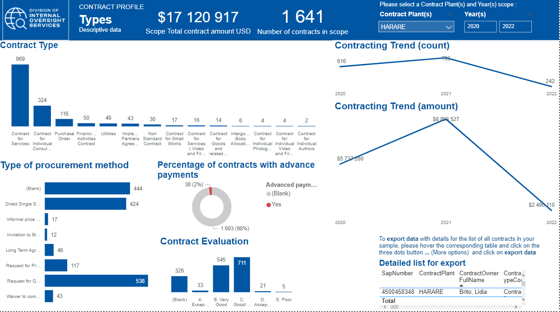

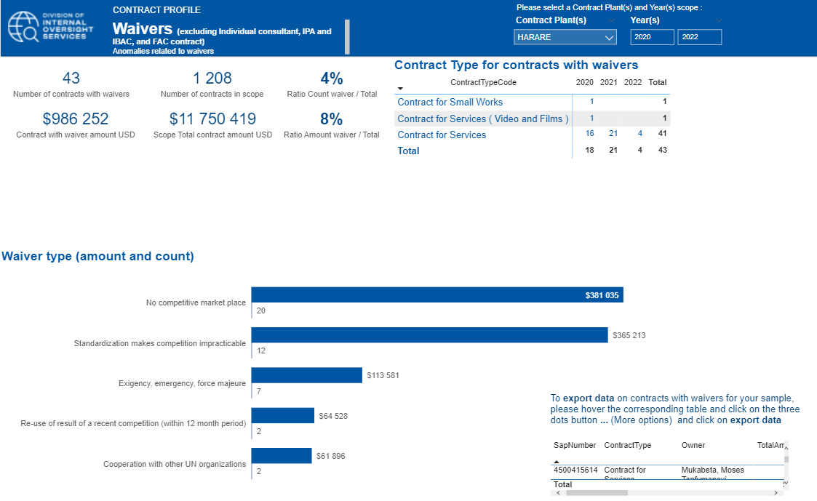

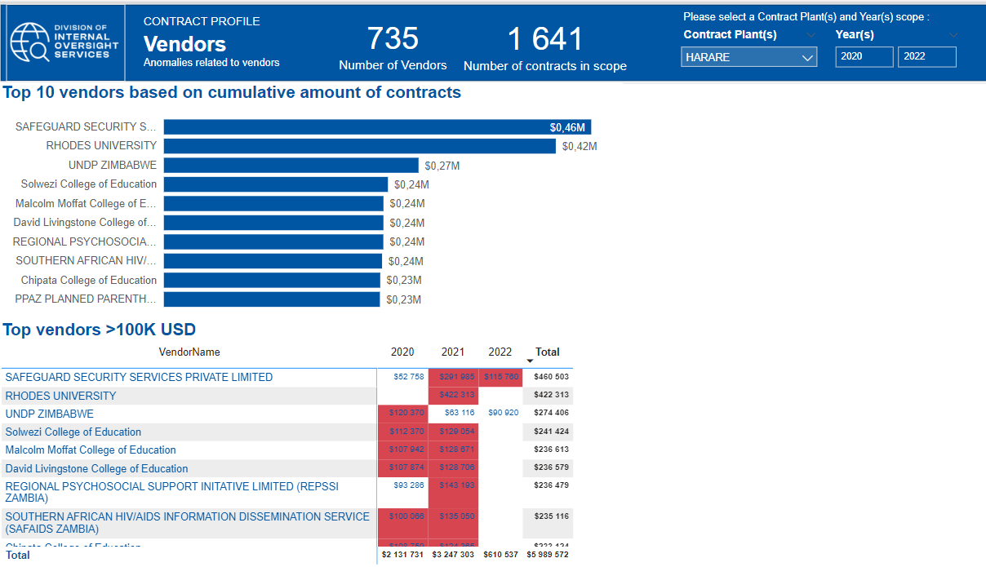

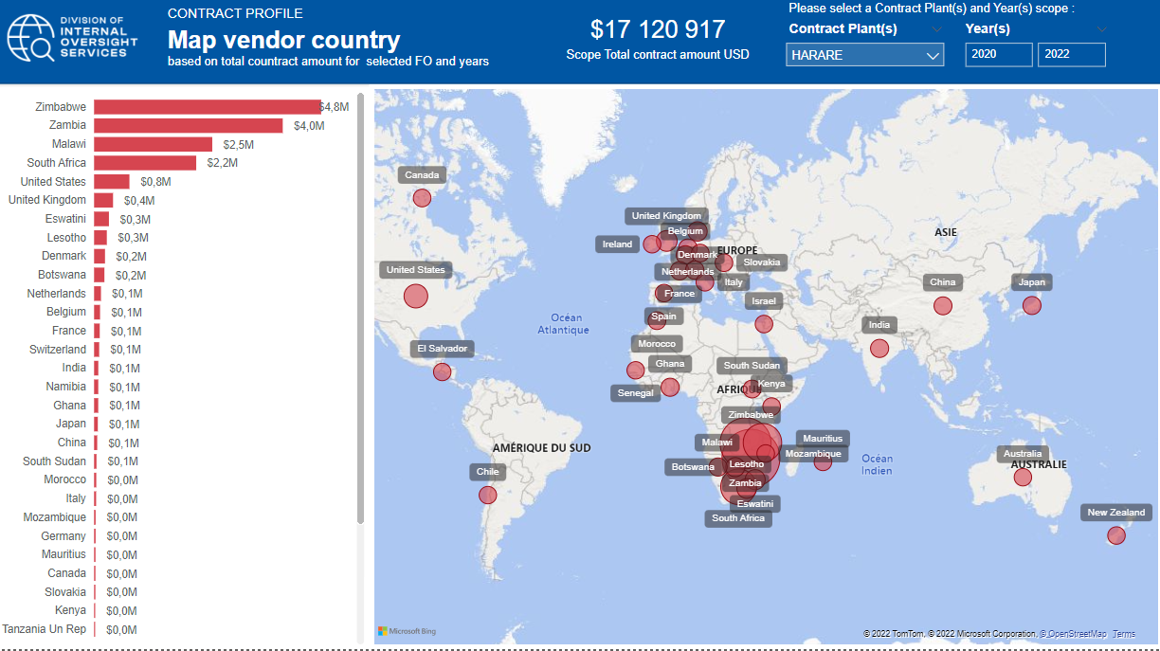

|  |
| --- |
| INFORMATION AND COMMUNICATION |

**Internal reports used and systems for data extraction**

* The Office uses the corporate tools iRIS

**External reports and target audience, including any feedback from the audience**

**Social media reports for any positive or negative press about the programme/projects:**

The office maintains a website in English with links to UNESCO news as well as publications relevant to the country.

* ROSA’s Communication and Visibility Strategy thus seeks to make the Office’s mission and programmes known to the wider public; maintain effective media relations; strengthen communications with various partners including National Commissions for UNESCO in the region, NGOs, Government ministries and departments as well as development partners; and strategically position ROSA within the UN system in the region and demonstrate its impact in achieving sustainable development goals.

Publication data

* Rosa has a publication plan for ED, SC, CLT, CI and DIR office, not publications were foreseen for SHS. There is no publication with ISBN.

|  |
| --- |
| PRELIMINARY FINDINGS |

Office objectives/Strategies issues:

* Non-operational regional strategy 2017-2021

1. Results framework provides a high-level view of various strategies that impact the office. However, the alignment or connection of how these strategies cannot be established as there are no concrete KPIs or linkages between various frameworks.
2. Goals are defined by unverifiable as key performance indicators are not embedded across the result chain.
3. This framework is very theoretical, it allowed the Office to approach donors and to show some alignment with SADC. Realistically the Office mobilized only for inclusive social development.
4. Too many strategies in one framework i.e C/4 and C/5, Agenda 2030, AU 2063, JPA SADC, UNESCO Priority Africa, Gender, National Deve. Plan, UCS, UNSDCF
5. The former Director reported that the coordination of programme for 9 countries in the region presents a challenge. The approach cannot be simply by dividing available RP budget for each line of action to each of the countries. This would lead to fragmentation and lack of impact. e.g. for ED Sector, which typically has the highest allocation of RP budget of some 450,000 US$/biennium, this would mean 450K$/9 countries/9 expected results = 50 US$ per activity per country.
6. UCS: Non-existent UCS documents for five countries out of nine of Southern African region. The UCS (UNESCO Country Strategies) for Zimbabwe exist for the earlier period but, however, now it is not being updated as the process is not clear at HQ level. BSP is supposed to guide FOs, in the past it was responsibility of PAX.
7. Pillar 2 of UNSDCF in Zimbabwe “Planet, Strategic priority 2 Environmental protection, climate resilience and natural resource management” is not supported by UNESCO. Even though UNESCO Harare Office has projects in this area. Why?
8. The Director reports that the office project portfolio is cross sectoral in nature. It should be verified to see if this is the case.

* Collaboration with the UN

1. The very peculiar context the UN is operating in Southern Africa in general, and in Zimbabwe in particular - the UN tend to depict itself as an Implementation Partner (IP) of the Donors, providing basic commodities and services, sometimes substituting the States. Such a business model is not healthy and is penalizing Specialized Agencies such as UNESCO whose model is technical support, policy advice, and international collaboration. Such a model also creates a transactional relation between the UN/Donors/Gvt, thereby creating a Donor-driven approach in the UN, and unsustainable policy delivery by the Gvt (constantly asking for basic assistance). This model is particularly present in Zimbabwe, where the Western Member States impose sanctions - curtailing the national economy and DFI in the country - and at the same time fund the humanitarian and social programmes to support the most vulnerable, using the UN as an implementation arm/vehicle. This is not sustainable, and UNESCO's broad mandate and expertise are therefore not benefiting the country, because it is not fitting in the transactional model.

* Program Partnerships

1. Partners like SADC are not competent in all domains and severely understaffed
2. SADC is based in Botswana and provides an optimum contact with government ministries in 19 countries. The UNESCO coverage of these countries unlike the UN, is split by three offices i.e., Harare, Nairobi and Yaoundé. The reporting lines are not always clear, i.e., staff working in Nairobi for O3 programme report to Patricia, P5 in Harare. Further, SADC provides staff for Education, Science but has limited human resources in other areas such as Culture and Communication. Efforts are being made to second staff from member countries to fulfil its critical role. Finally, the roles of national commissions vis-à-vis SADC and the office need to be clear.

* Organization change

1. Risk 3: Organizational transformation

Failure to initiate, integrate and execute changes deriving/stemming from Organization/strategic transformations and reforms.

Recruit a dedicated communications officer to focus on planning of communication and messages communicate UNESCO's priorities and achievements; Active participation in UNCT; Integration of UN reform processes and contents in organizational discussions and meetings at all levels.

*what strategic changes does the office want to make? if yes, who would lead this change effort? the communications office would support but may not lead this change?*

Field Accountability:

* The accountability of six antenna location is not formalized. These antennas are not even in the scope of the UNESCO field security domains.
* There is no local AO and some are single person location and lack segregation of duty, there are no means to verify the implementation and delivery of programs
* Without formal recognition as UNESCO entities, antenna locations can be present risks in terms staff security, weak knowledge and application of UNESCO rules and procedures by staff. Not all the activities are in Harare – that is the biggest risk.
* Risk 1: Accountability: Failure to establish and disseminate a clear accountability framework that achieves the right balance between centralization and decentralization (including true delegation of authority to the field) leads to bottlenecks in decision-making and impacts the Office ability to meet UNESCO's strategic goals
  + Opportunity: To develop more transversal projects that leverage on successful projects in other Offices and or Regions
  + Establish open communication at level of Directors/ Heads of Office, Head of Units level to promote information sharing and joint actions / Internal PS discussions with invitation extended to HoO for the region to establish a common understanding of country and regional initiatives

Resource Mobilization Strategy:

* The RM efforts did not develop in a balanced manner, and this has led to some unbalance in funding both geographically (with main funding in countries like Zambia, Malawi), and thematically (mainly ED and SC sector);
* SC Sector capacity in the Office was very low for much of the time covered by this report (only one P5 for the period 2015-2018); Once the SC capacity was strengthened by the recruitment/transfer of a P3 and P4 staff, the RM initiatives led by this Sector also rose sharply, with a range of new projects in different countries (Mozambique, South Africa, Zimbabwe), on different themes ( water, Renewable energy/ICTs), and supported by different funding sources.
* Several (senior) PS lacked RM experience and skills, and there has been little guidance and capacity building offered from HQ to work on this. ED Head capacity to mobilise resources was a major hindrance to build on clear opportunities that presented itself in the ED Sector in the region. I recommend that the selection of the new Head of ED must consider the skills and proven experience of the incumbent in RM.
* The continued competition and even mission creep between UN agencies hinders RM for areas for which UNESCO would be well positioned (example, UNESCO has not been able to participate in the implementation of GPE funding coordinated by UNICEF, despite repeated efforts and discussions).
* RM efforts are uneven e.g., No EXB in CI while there are important needs from Member States

Weakness and gaps in RM proposals:

* Lack of clarity on the approval process in cases of project funded by joint UN funds where the local UNRC has delegated authority and UNESCO is part of the UN signatory team.
* There is unclear accountability between project signed locally with the UNRC versus projects signed by DIR/BSP and other HQ approvals.
  1. SC project “Catalysing Investment into Renewable Energy for the Acceleration of the Attainment of the Sustainable Development Goals in Zimbabwe” project was reviewed by the High-Risk Committee on May 18. It is a UN joint project. It was agreed to move on with the project but the office needs to make some adjustments, i.e. reduce UNESCO budget and to do technical adjustments to the programmatic aspect of the project document (page 4) be made to reflect the discussion of the Committee;
  2. ED project in Malawi , Skills and Technical Education Programme (STEP), was signed without proper due process as well.
  3. The SC project proposal to Adaptation Fund for 5 Millions USD on sustainability of groundwater in Zimbabwe was approved earlier 2021. Though the full proposal was submitted to the donor without prior international validation. The enclosure of information on the breakdown of management costs was provided without BSP’s clearance and thus might have established a precedence. How was it managed? New project Be resilient to be added.
* Recruitment of project appointments is inconsistent. e.g., CLT and SHS resource mobilization efforts do not include HR components. Therefore, there are delays in project implementation.
* Projects negotiated with co-financing prior to consultation with HQ = fait accompli – increasing workload at the Office and HQ level when it comes to the preparation of the financial report – e.g., SDC project.

- O3 project complex reporting due to co-financing

- really difficult to monitor expenses specially as this data comes from antenna locations and is not independently verified. Unclear on financial information the Office may have shared with donors.

* SISTER Template 12888, ED TEACH programme (218ZIM1000) financed by UNICEF. With many back and forth, the SISTER template is yet to be finalized. Funds have been received more than one year ago. Why and what is the status today.
* There is no problem with funding. When you have an Extrabudgetary project, one has to get a PA for projects >500 K. They should make provision for that e.g., Adaptation project made provision for PA.

Project management issues:

* Especially for larger projects more attention needs to be given to Planning and Implementation. The Office has seen both poor (EU STEP) and excellent (O3) examples of this.
* Delay in obtaining responses for project status in addition to delay in closure process at the Office level e.g., project 549MLW1000 putting UNESCO in difficulties vis-à-vis the donor (EU).
* Weak capacity in SC, SHS, CLT
* Project closure delays - Projects that are TECO - 261ZIM3000 - Advancing the Rights of Women and Girls - SHS; 549MLW1000 – STEP.
* STEP (Malawi)

- Major donor EU micromanaging the overall project - fragile balance between UNESCO and EU

- Recruitment of project staff Quality Assurance was taking too long and rejected by HQ. - With the pandemic, both project leader and assistant left Malawi and, hence, the project was abandoned.

- Team Leader was imposed by the donor. - Significant implementation, posting and closure delay the STEP project in Malawi: Implementation of Skills Technical Education Programme (STEP) 549MLW1000 was severely impacted when at the onset of COVID internationally recruited project staff left Malawi. The former project manager struggled to comply with UNESCO Financial Regulations and Rules resulting in a complex reconciliation of roll-over funds and post facto approval of activities as part of the project closure exercise which is still ongoing at time of writing.

- Was an incompetent team manager and did not follow UNESCO rules but rather ILO rules, i.e., the team Leader organized some workshops without proper validation process where instead of waiting for PROSPER payment, the balance from previous workshops were used to organize new workshop. Check FR for meetings & conferences.

- The Office vehicle, as well as ICT equipment purchased under STEP project shall be transferred to the Ministry of Labour. This transfer of ownership shall be documented. Verify whether it was done.

- Removal benefits granted to one of the former project appointment staff. The current AO raised concerns with the former AO that PO 4500420572 provided for the removal of a private motor vehicle. Project appointments are authorized to transport 1000 kgs at UNESCO’s expense and no removal of household goods is provided for.

* O3

- Antennas faces HR capacity problems

- Social and cultural constraints around the acceptability of comprehensive sexuality education (CSE) at community level. Opposition to CSE, with increasing levels witnessed in countries such as Ethiopia, Ghana, Kenya, Mali, Namibia, South Africa, Uganda, and Zambia.

- Absence of laws aligned to international and continental commitments notably relating to the age of consent to sexual activity and marriage, and access to comprehensive SRH services, such as contraceptive services and preventive SRH services

- Operational challenges to scale up CSE and ensure its quality delivery. Challenges in the delivery of CSE through online platforms in some countries, particularly due to limited access to the internet and access to smart phones or computers by both teachers and learners,

- Limited domestic funding for CSE; huge reliance on donor funding with challenges for sustainability

- COVID pandemic which negatively impacted implementation of planned activities. Overall, efforts to advance CSE and access to sexual and reproductive health (SRH) services for adolescents and young people (AYP) were generally undermined at the beginning of the pandemic due to school closures and lockdowns more broadly in countries.

- Shortage of staff implementing the programme in some countries due to delays with staff recruitments (HRM)

- 501RAF1001, O3 Plus financed by Swiss: SDC has strict co-financing requirement where UNESCO’s parallel funding shall be equal to 50-50 and in this case, besides UNESCO’s parallel funding, the 3rd party in-kind contribution is also involved. How was it done?

* CLT Regional Project "Culture, Public Spaces and Sustainable Cities" discontinued by the Donor (Flanders)

- The project budget was $US250,000 and the project had a geographical focus of southern Africa: Zimbabwe and South Africa ($US125,687) and a Global focus ($US142,312). The project was to be implemented between January 2019 and the end of January 2020.

- Changes to the UNESCO staff in the Harare Office and a restructuring of the Culture Sector may have contributed to this delay in commissioning of the study and the delay was exacerbated by difficulties in identifying experts willing to complete the study. As a result the Donor decided to discontinue the project.

* SHS projects: The two main challenges:
* Lack of staff. SHS never has capacity in the Field and implements as one person the whole programme incl. ExB and RP. For the first time, Harare was able to create a NOA position for the next 2 years – project appointment. Overall, there are 6 people, incl. 2 interns from the University for 1 year. From 1st of June, a sponsored Chinese expert will join the team.
* Difficulty to become regional since there is no staff in other 9 countries under Harare Office. Activities are primarily based in Zimbabwe. For instance, Zambian gov requested the review of their youth policy, however, there is a staffing challenge. Temporary O3 teams support SHS in Zambia (backstopping). They will eventually need more support.

Human resources

* Survey findings (43% response rate, 47 out of 109 employees replied):
* 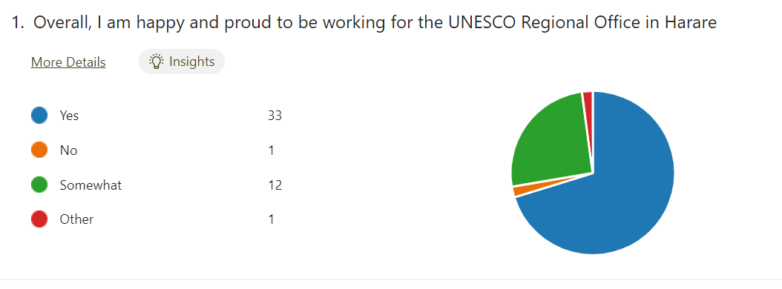Overall, Harare staff are happy and proud to be part of UNESCO (70%).
* Overall, staff positively assessed their managers.

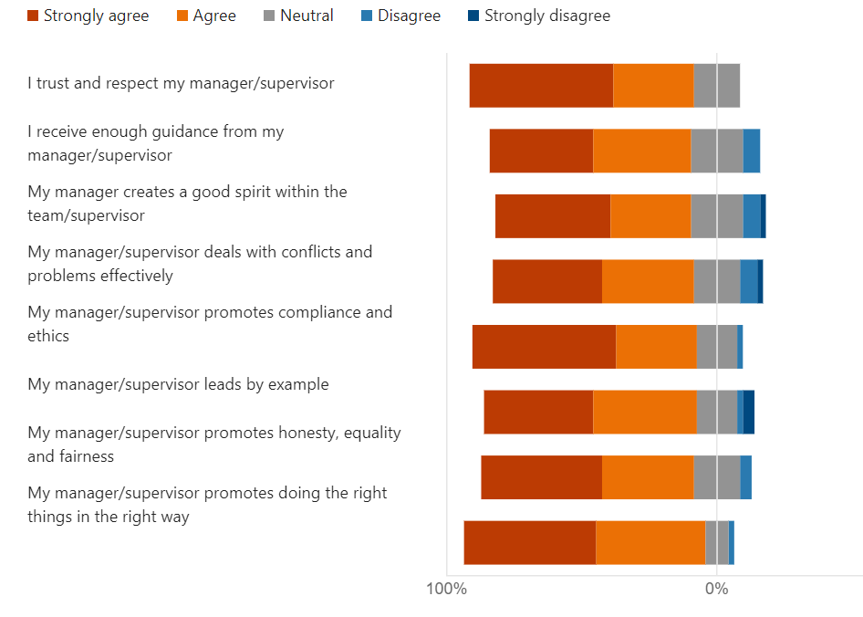

* Three persons stated that they observed fraud. The details are below:

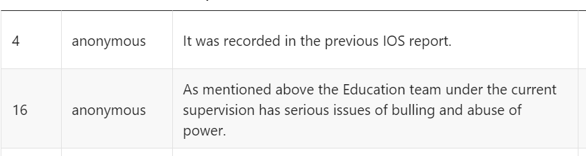

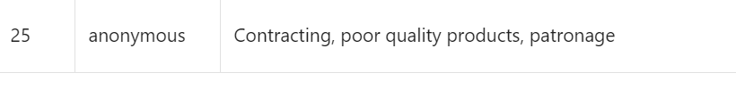

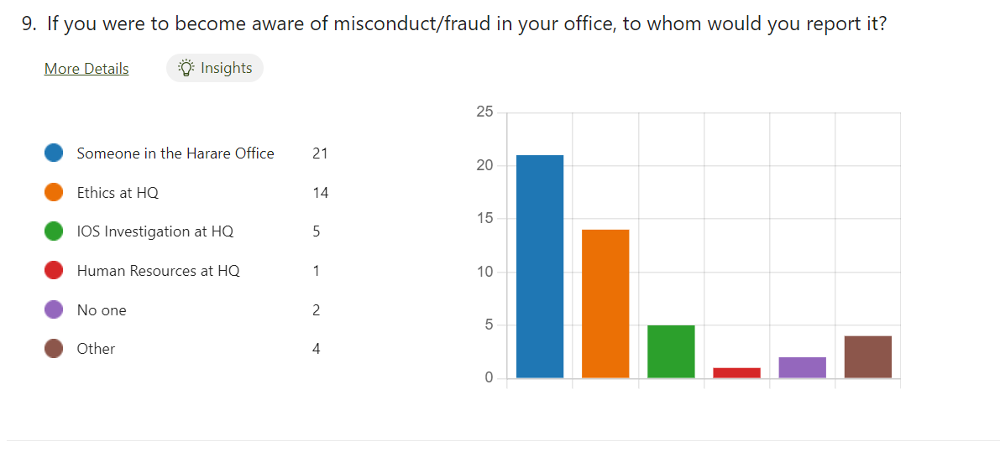

* Fraud and moral harassment related observations
* Staff being morally harassed by ED head who retired in May 2022.
* It would be important to clearly demonstrate how cases previously reported to IOS have been handled to improve confidence in the system. Fear keeps many from not taking any action.
* It is easy to hide corruption. There have been historical fraud issues and there are still there. So it really doesn’t matter to raise them.
* HR matters
* Project Appointment based in Harare while duty station is Johannesburg: An International Staff – Project Appointment, holding Zimbabwean Nationality and assigned to a project position established in Johannesburg South Africa, post number 6ZAED 0012PA, is in fact based in Harare Zimbabwe. There is no indication of this out-posting in IRIS or any higher-level approval for this, other than at Regional Office level. The former Regional Director rationalized this situation by referring to the large scale extrabudgetary funding the staff (PA) is mobilizing and managing, and it was his preference for the individual to be based in Harare. The conditions in South Africa (please see comments on the necessity to open accounts in South Africa instead of using UNDP accounts) do not permit to manage such a large project. Furthermore, the Staff is the Head of Unit for Education for Health and Well-Being and a valuable member of the Office SMT. *Audit to analyze how to regularize this situation without jeopardizing the implementation of this important programme.*
* There have been several cases where HRM/Sectors have not been respecting the Standard Duration of Assignment. One case led to serious mental distress of the P4 fixed term staff, with potentially severe consequences in the office (incl a planned attack by the individual). This shows that UNESCO HQ needs to listen better to FO Heads when they express concern about staff members who would benefit from a transfer (DIR/FO had repeatedly insisted with HRM and Sector to transfer the staff to HQ).
* Another case relates to the Head of ED Unit - P5, who after 5 years in the C-level hardship duty station (with SDA 4 years) insisted that she should not be transferred, as she would soon have less than 3 years before retirement. The ED Sector HR agreed with the staff without checking with the FO DIR, and this led to a situation where this staff will serve for almost 8 years in a C-level hardship duty station. This is not recommendable, the more since there were serious issues with the management of staff in the Unit.
* *DIR/FO recommend that ED Sector appoints a strong candidate with good capacity/skills in team building, RM, and planning, for this important position. If the right candidate is appointed, I predict that the ED portfolio for the Region, and collaboration with SADC will flourish.*
* A more general staff issue was that the office had a number of SC contract staff who had been with the office already for a very long time (over 15 years) and were simply renewed every year. Several of these SC contracts, however, were not very productive, and would not be selected in case of a competitive process. To avoid similar challenges in future, and considering that several of the long term SC staff were not far from retirement, I introduced two measures:
  + For all new SC contracts (and for those below 7 years duration), the hiring Unit should advertise the Post every 2 years, with the incumbent being able to re-apply. This allows updating the ToR and checking the market for best candidates.
  + SC contracts longer than 7 years would be continued till retirement date (62 years was maintained even though UNESCO adjusted retirement age to 65 y some time ago).
* The current Director requested whether the audit were to perform an analysis of the AO Units’ workload and staff grades, this can inform the Office on the capacity required and recommended grading.

Contracting and Procurement

|  |  |  |  |  |  |
| --- | --- | --- | --- | --- | --- |
| **Commitment item** | **Commitment item Name** | **2020** | **2021** | **2022** | **Grand Total** |
| **11** | Consultants/Experts | 931 209 | 945 847 | 121 343 | 1 998 399 |
| **20** | Contracted Services | 3 935 855 | 6 582 347 | 1 249 749 | 11 767 951 |
| **40** | Equipment and Maintenance | 262 727 | 646 989 | 64 555 | 974 270 |
| **50** | Other expenses | 255 515 | 348 860 | 135 961 | 740 337 |
| **Grand Total** |  | **5 385 305** | **8 524 044** | **1 571 608** | **15 480 957** |

* The office does not have a procurement plan. The total material of contracting procurement for the audit period 1 January 2020 to 31 March 2022 is $ 15.5 M covering consultants/experts, contracted services, equipment and maintenance, other expenses. Without a procurement plan, there is a risk of poor procurement planning and unrealistic timeline for PA and other temp personnel selection, not following up on receipt and quality of deliverables on a timely basis and of payment delays because of slow sign off by bank signatories results in loss of credibility with contractors, donors, partners, and senior management at HQ.
* There is a need to further analyse why with such big project portfolios that contracts are not submitted to Contract Committee for review. Despite large project portfolio, procurement is relatively low. Very few contracts going through CC.
* The Office operates in an environment that is characterized by economic volatility, and a subculture exists whereby costs can be inflated. The AO and team do monitor this closely and have taken steps to diversify suppliers to discourage a dependency relationship being built especially for standard goods and services e.g., catering.
* Antennas not formalized and rely on staff recruited outside of UNESCO (under PA or consultant modality) who are not knowledgeable of UNESCO rules and regulations.
* In relation to IPA,

- no capacity to do proper reporting (both narrative and financial) or evaluation. FOs rely on partners and sometimes don’t even check reports/evaluations. There should be a balance between outsourcing and what is being done by the Office itself.

- Potential conflict of interest: a PA gives a preference to a certain NGO for IPA implementation.

VAT

* Currently the VAT account has a backlog of refunds received but has not allocated them to the relevant budget codes. This is work-in-progress however some refunds were so delayed that the budget codes have already been closed in prior biennia.

Travel

* Unplanned missions amount up to 27 percent. Last minute travel resulting in numerous derogations.

Potential Financial control weaknesses

* Instances of purchase data indicate cross-charging at the end of the year (PO #).
* Need to verify vendor details in banking tools versus SAP data.
* Travel Orders, Purchase Orders, Good Receipt notes, Meeting and Conference FRs were not liquidated on a timely basis and used for unauthorized purposes e.g., STEP project
* Four staff members, one in Harare and three in Lusaka, Halimani, Lucas, Mukonka, Remmy, Mumbi, Mwilu Lenard and Saili, Alice have limits for authorizing bank payments. NB need to test payments authorized by these staff.

|  |
| --- |
| AUDIT RATIONALE, SCOPE AND OBJECTIVE |

**Audit rationale**

The Office was last audited by IOS in for the review of the consolidated financial statements.

**Audit objective**

The objective of the audit is to provide assurance on the effectiveness of internal controls, governance, and risk management processes of the San Jose Office. Furthermore, review the efficiency, effectiveness, and economy of the Office’s operations (including programme management, financial controls, procurement, travel, human resources management, security, IT, and general administration).

**Audit scope and period**

The audit will cover the Programme activities from 1 January 2020 to 31 March 2022, the audit team may also review other periods if necessary. The audit is planned as a full scope exercise. The audit will cover the following areas:

* Overall governance of the Office (including objective setting, planning, and risk management)
* Programme
* Financial control
* Contracting and procurement
* Travel
* Human resources
* General administration

**Audit methodology**

The audit will be performed in accordance with the *International Standards for the Professional Practice of Internal Auditing* and OS audit manual.

The audit will assess the functioning of internal controls within the defined scope in order to identify major risks to the achievement of the San Jose objectives. Action plans will be agreed to strengthen risk management and controls, and to improve operations where warranted.

The audit will be based on surveys, interviews, data analysis, documentation review, etc. The audit team will select the sampling techniques such as judgemental, statistical, representative, etc. to ensure the sampling approach remains relevant to the test objectives.

**Key milestones**

IOS will conduct the audit of the Office per these timelines:

| **Milestone** | **Planned date** |
| --- | --- |
| Notification letter | 25 April 2022 |
| End of planning | 24 June 2022 |
| End of fieldwork | 29 July 2022 |
| Draft report | 31 August 2022 |
| Final report | 30 September 2022 |

**Audit resources**

The budgeted days for this assignment are 110 days as follows:

|  |  |  |  |  |  |
| --- | --- | --- | --- | --- | --- |
| **Activity/ Persons-days** | **Planning** | **Fieldwork** | **Draft report** | **Finalization** | **Total** |
| Head of Audit (Soriano) | 2 | 0 | 2 | 2 | 6 |
| Principal Auditor (Pise) | 6 | 14 | 10 | 5 | 35 |
| Associate Auditor (Beltyukova) | 6 | 18 | 10 | 5 | 39 |
| Total | 14 | 32 | 22 | 12 | 80 |

|  |
| --- |
| Annex 1 – Risk Matrix and Work Programme |

.

|  |
| --- |
| Engagement Terms of Reference*Title of the Audit* |

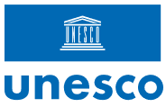Terms of Reference to be shared with the audit client at the end of the audit planning phase.

****Background****

This audit was included in IOS 2022/2023 Audit Work Plan. In response to Executive Board request[2] to achieving complete coverage in a 5-year cycle, IOS/AUD has developed a field office network strategy for the period 2022-2026 to increases the frequency of audits of field offices.

****Audit scope and period****

The audit will cover the office activities from 1 January 2020 to 31 March 2022, the audit team may also review other periods if necessary.

This audit will focus on the following main areas:

* Overall governance of the Office (including objective setting, planning, and risk management)
* Programme
* Financial control
* Contracting and procurement
* Travel
* Human resources
* General administration

****Objectives****

The audit objective is to provide assurance to the Director-General on the effective functioning of the Office’s internal controls, as well as the efficiency, effectiveness, and economy of the Office’s operations.

The audit will assess the adequacy of the internal controls to achieve the office objectives. IOS/AUD will discuss with the audit clients Agreed Management Actions (AMA) to strengthen risk management and controls, and to improve operations where warranted.

****Audit methodology****

The audit will be performed in accordance with the *International Standards for the Professional Practice of Internal Auditing* and IOS audit manual.

The audit will be based on surveys, interviews with internal and external stakeholders, walkthroughs of processes, data analysis and documentation review. The audit team will select the sampling techniques such as judgemental (risk-based), statistical, representative sample to ensure the approach remains relevant to the test objectives.

****Stakeholder engagement form****

IOS will conduct the audit as per the workflow and timelines below. Without any objection from your end, IOS considers that you agree to adhere to these timelines.

Respecting agreed timelines allows IOS to deliver the audit plan on time and to better serve the Organization. As delays impact the implementation of other assignments, IOS would appreciate to be informed as soon as possible of any challenges that would affect the agreed timeline.

|  |  |
| --- | --- |
| Milestone | Planned date |
| Notification letter | 20 April 2022 |
| TORs shared with audit client | 24 June 2022 |
| Entrance Meeting | 12 May 2022 |
| Initial Risk Assessment / Start of Fieldwork | 16 May 2022 |
| Exit Meeting / End of Fieldwork | 29 July 2022 |
| Draft report | 31 August 2022 |
| Client comments and AMAs | 15 September 2022 |
| Final report | 30 September 2022 |
| Client Satisfaction survey | 30 September 2022 |
| Release of AMAs in TM+ | 31 October 2022 |

****Audit resources****

The audit will be carried out by Mr Sameer Pise, Principal Auditor, and Ms Anastasia Beltyukova, Associate Auditor

1. https://hdr.undp.org/en/content/download-data
2. 211 EX/44 decision